Earthwatch Institute India

1. Earthwatch Institute India

1.1 Welcome to the learning resource on air quality
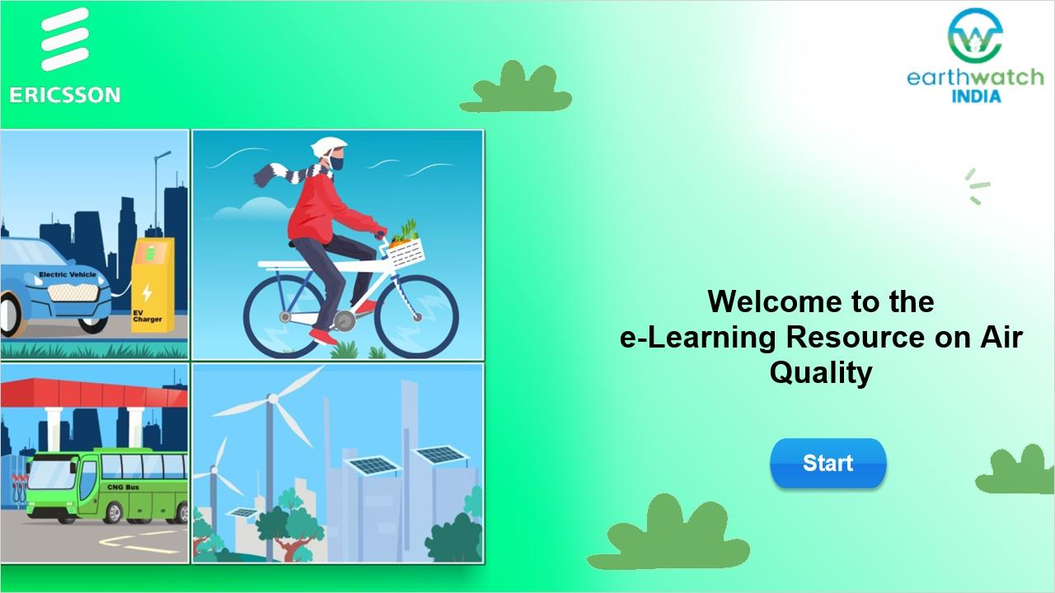
Notes:
Welcome to the E-Learning module on Air Quality.
Click start to begin.

1.2 Learning Objectives
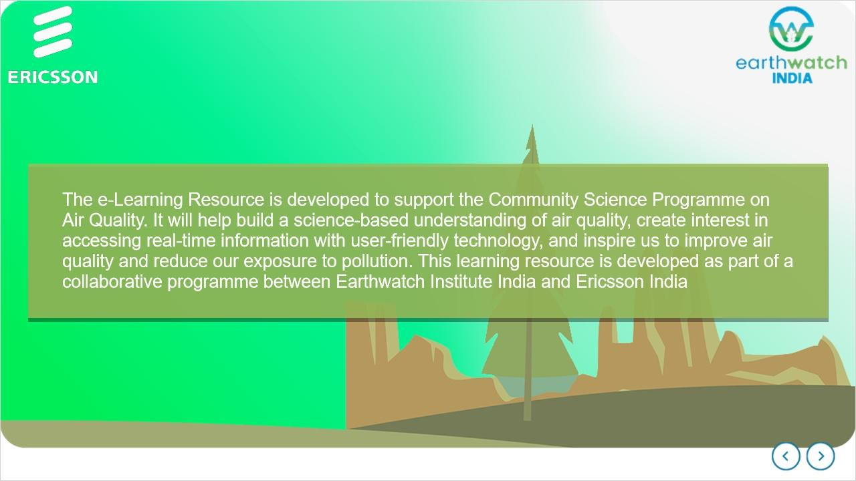
Notes:
The e-Learning Resource is developed to support the Community Science Programme on Air Quality.
It will help build a science-based understanding of air quality, create interest in accessing real-time information with user-friendly technology, and inspire us to help improve air quality and reduce our exposure to pollution. This learning resource is developed as part of a collaborative programme between Earthwatch Institute India and Ericsson India

1.3 Learning Objectives
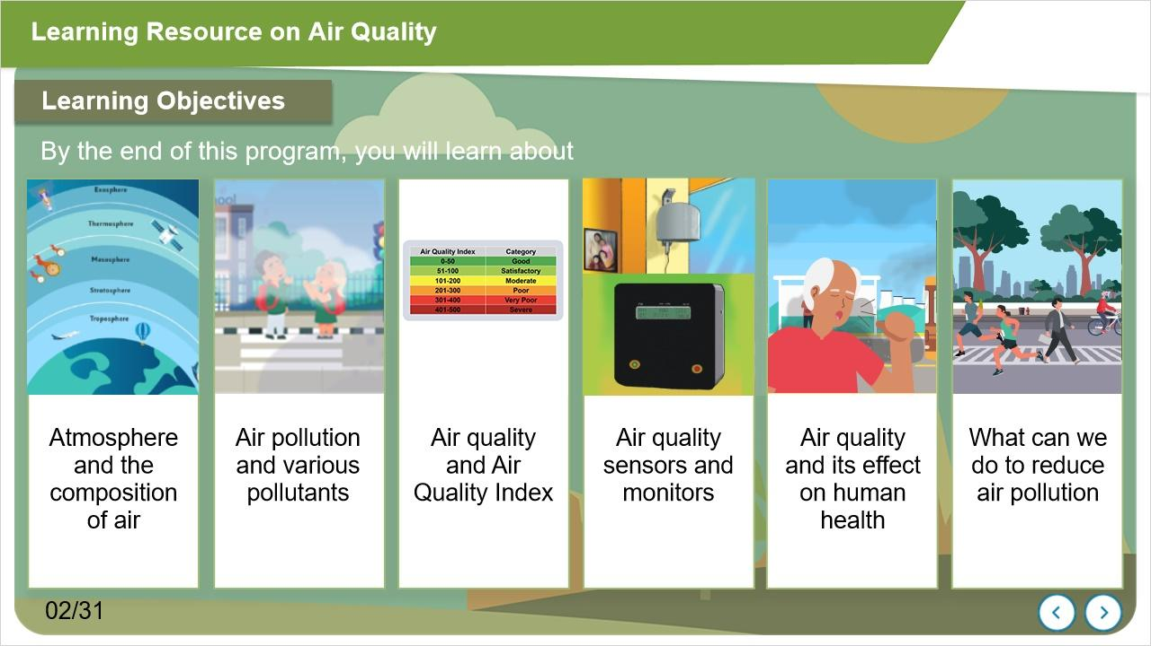
Notes:
This programme will help you learn about the atmosphere and the composition of air; causes and sources of air pollution. It will help you learn about the Air Quality Index (AQI). The programme will inform about small air quality sensors and monitors and their use for real-time monitoring and educational purposes. You will learn about the possible effect of pollution on human health, and finally, you will also learn about what we can do to improve air quality.

1.4 Menu
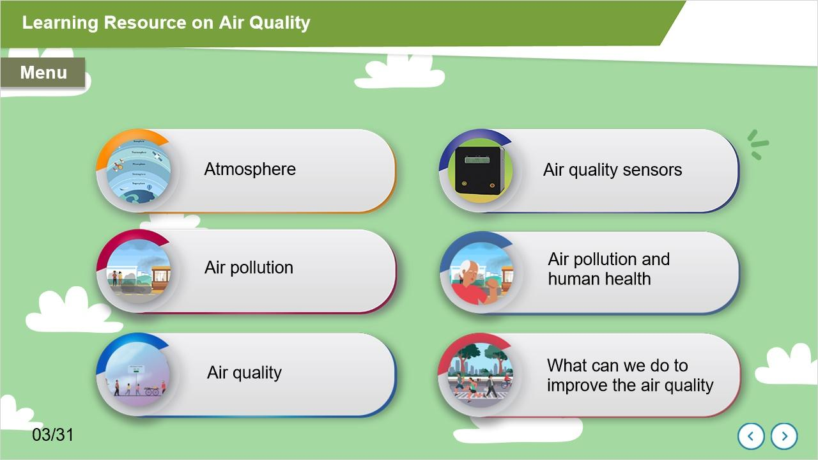
Notes:
The learning programme comprises six modules: Atmosphere, Air Pollution, Air Quality, Air Quality Sensors, Possible effect of Air Pollution on human health, and What can we do to improve the air quality.

1.5 Atmosphere & layers of the Atmosphere
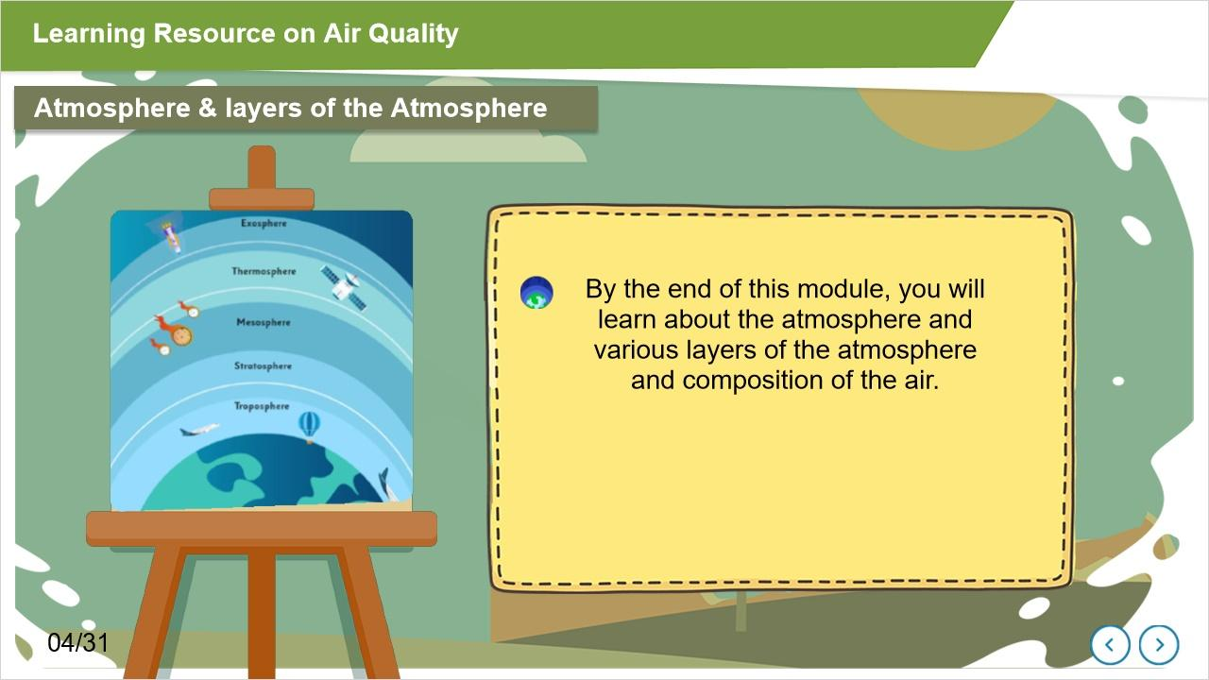
Notes:
The first module introduces the Atmosphere and layers of the Atmosphere.

1.6 Earth system can be broadly recognized as different spheres
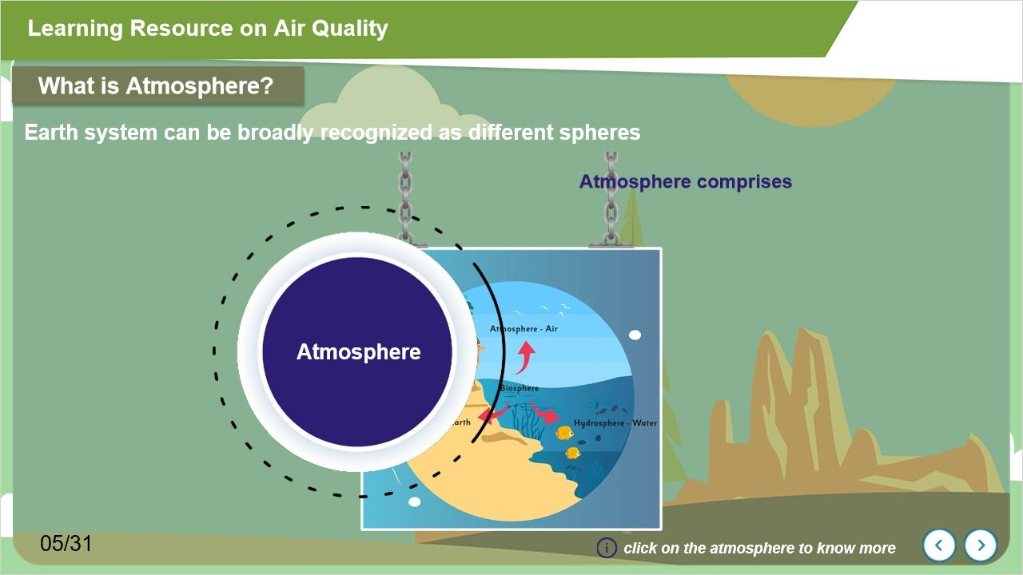
Notes:
Let's talk about the Atmosphere,

From what we know of our universe, Earth is the only planet in the universe where life exists in all its variety. Earth system can be broadly recognized as different spheres, like the Lithosphere, Hydrosphere, Atmosphere, and Biosphere.
The atmosphere comprises various gases, water vapour, and particulate matter, including dust. We cannot imagine our life without the presence of the atmosphere.
The layer of gases, commonly known as air, is the Earth's atmosphere; it is held around the planet by its gravity. Air also carries soot, smoke, and other particles, which are major contributors to air pollution.

1.7 Layers of Atmosphere
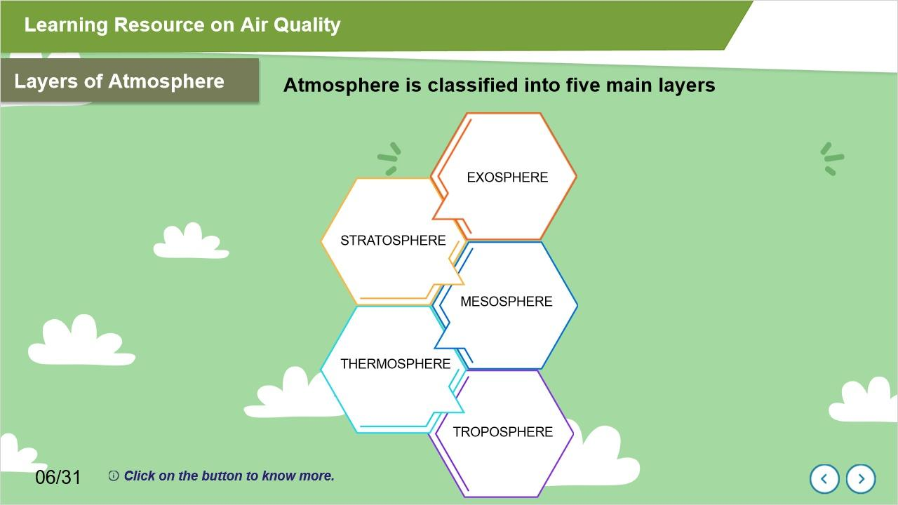
Notes:
Our atmosphere is classified into five main layers, as shown here.
Troposphere
Stratosphere
Mesosphere
Thermosphere and
Exosphere

Click on each tab to know more.

Here we are learning about the Troposphere Layer. It is the lowest layer of our atmosphere, and nearly 75-80% mass of the atmosphere is held within the troposphere. This layer extends upwards nearly 10 km above sea level from the Earth's surface. The troposphere supports most of the life on our planet, and we human beings also live in the troposphere. Almost all-weather that we experience occurs in this layer.

Above the troposphere lies the stratosphere, which extends from the top of the troposphere to about 50 km above the ground. The ozone layer is also found within this layer, which absorbs high-energy ultraviolet (UV) light from the Sun.

The mesosphere is the third layer of the atmosphere. The mesosphere goes up to 85km above the surface of the Earth.

Thermosphere extends from about 90 km to between 500 and 1,000 km. This layer has the highest temperature, which can range from about 500° C to 2,000° C or higher.

The exosphere is the uppermost layer of our planet.

1.8 Composition of Air
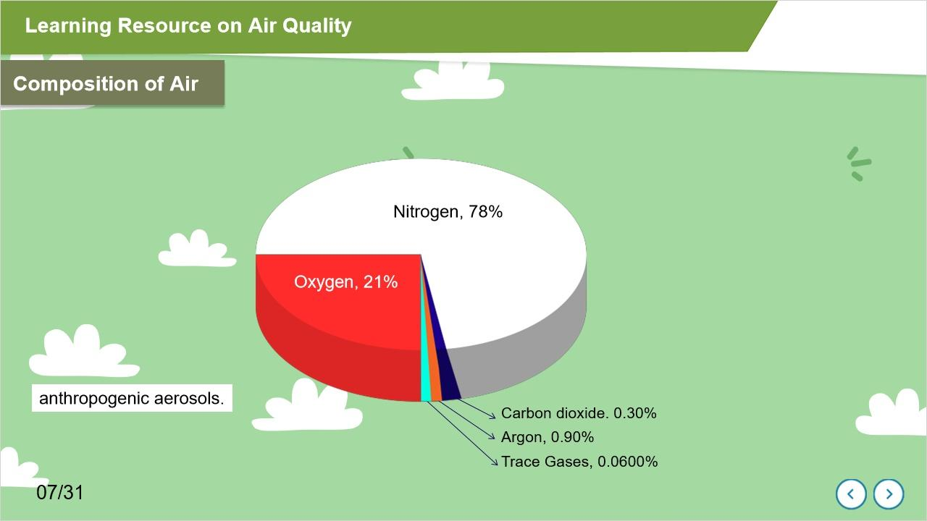
Notes:
99% of Earth's air is primarily composed of two main gases, nitrogen about 78%, and oxygen about 21%. Other gases are argon about 0.90%, carbon dioxide 0.30%, and the remaining gases in trace amounts.
There are many small particles, aerosols, water vapour and other gases present in the atmosphere.
Do you know what aerosols are?
Aerosols are minute solid particles or liquid droplets that are suspended in air or gases. Aerosols in the earth’s atmosphere can be natural or human-made. Fog, mist, dust are examples of natural aerosols, whereas smoke and particulate air pollutants are examples of anthropogenic aerosols.

1.9 Significance of the Air
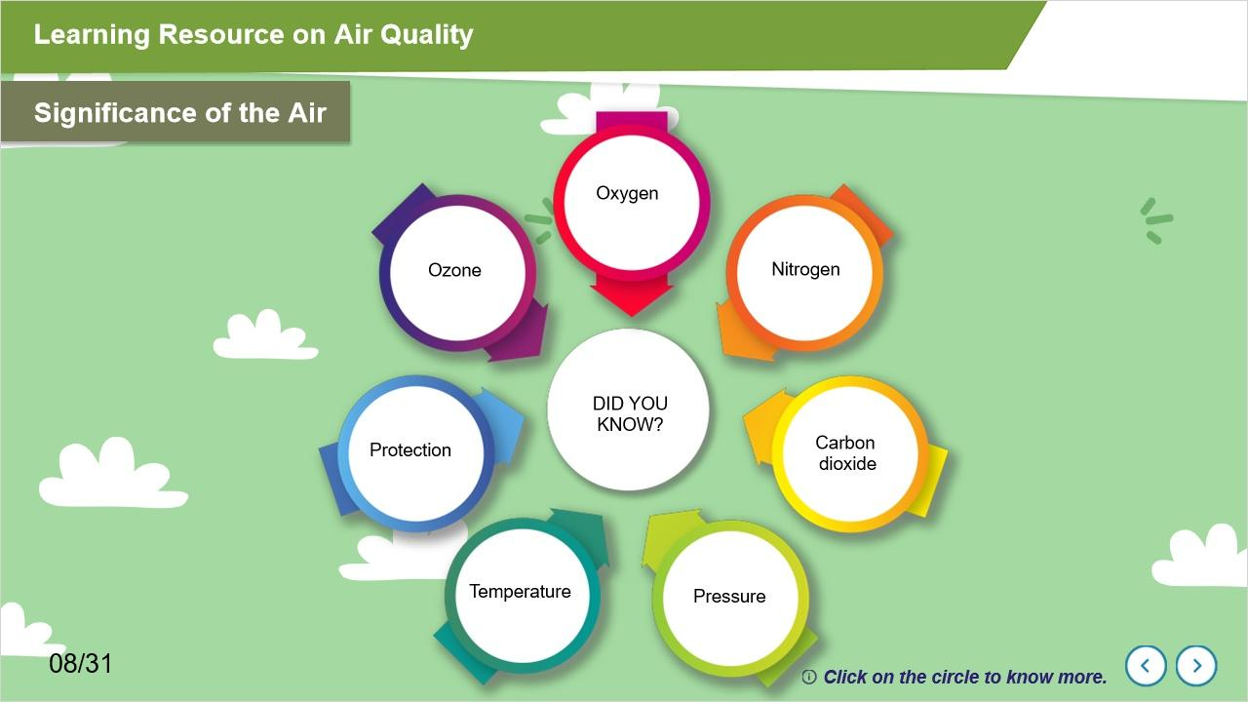
Notes:
As you know, the air is an essential element in our survival. Most organisms use oxygen for respiration. Carbon dioxide is used by plants for photosynthesis. High levels of carbon dioxide in the air increase Earth's temperature. Ozone protects us from too much sunlight and ultraviolet radiation.
In this section, you will know more about Oxygen, Nitrogen, Carbon-dioxide, Pressure, Temperature, Protection and Ozone
Click on the circle to know more.

1.10 Pollution
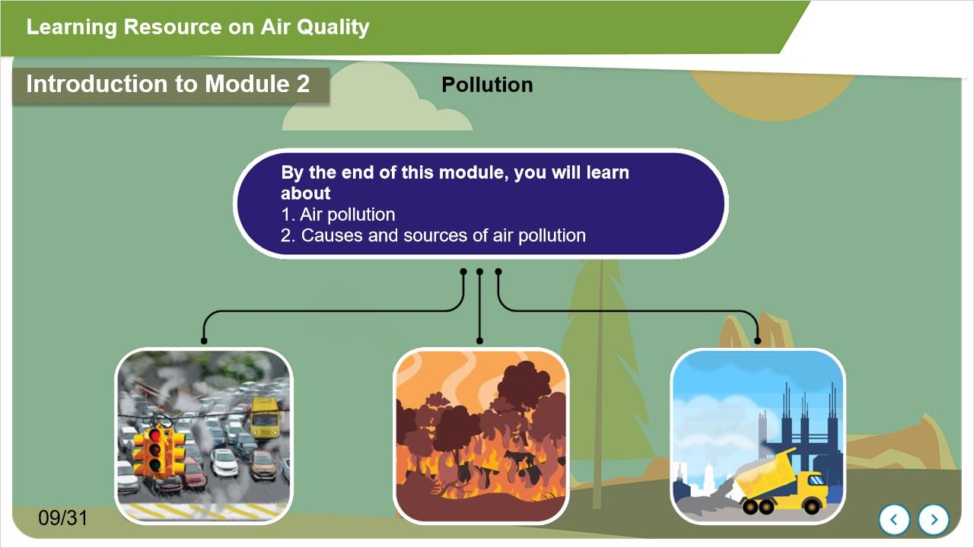
Notes:
Welcome to the second module of the program. Here we will discuss air pollution, its causes, and sources

1.11 Types of pollution
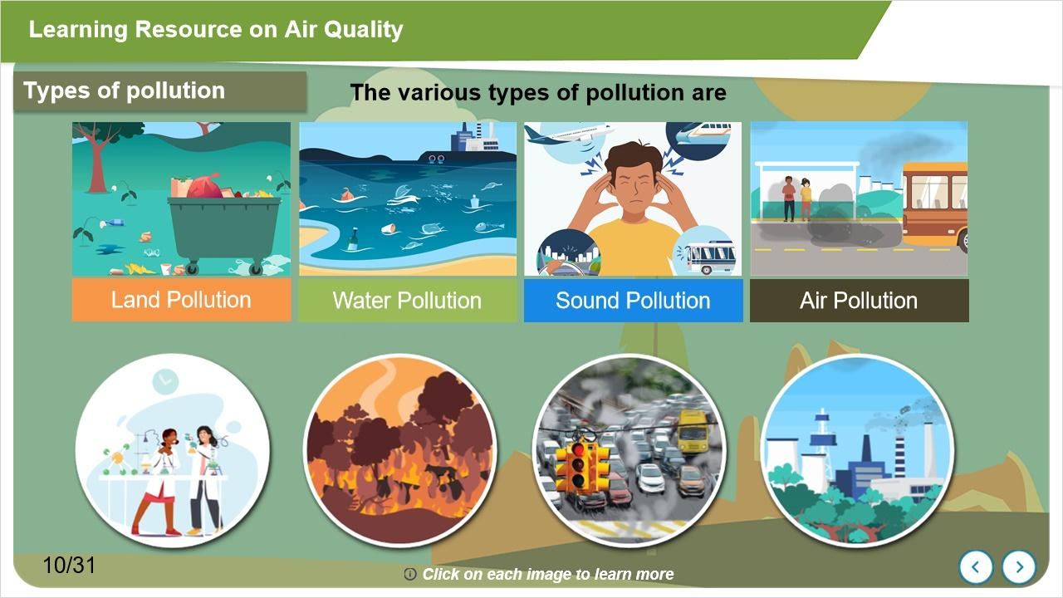
Notes:
There are four main types of pollution - land pollution, water pollution, sound pollution, and air pollution.
In this module, we will discuss about air pollution. The presence of air pollutants such as chemicals, particles, and toxic compounds makes the air polluted. These air pollutants are present in various forms like solid particles, liquid droplets, and gases.

1.12 Air Pollutants
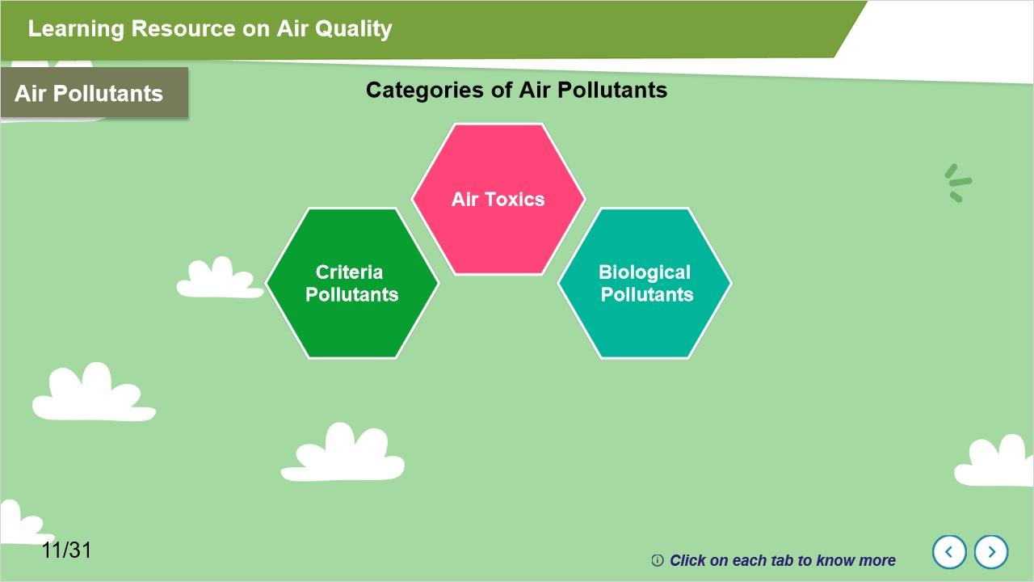
Notes:
There are three main categories of air pollutants such as criteria pollutants, air toxics, and biological pollutants.
Click on each circle to know more

Criteria pollutants are considered an indicator of air quality. Some of the criteria air pollutants are -
Carbon monoxide, Lead, Nitrogen dioxide, Ground-level Ozone, Particulate Matter, and Sulfur dioxide.

Air Toxics include organic compounds such as volatile organic compounds, polycyclic aromatic hydrocarbons.

Biological pollutants include skin and cells of humans and animals, molds, and waste of animals and insects.
Biological pollutants are mainly found in indoor air.

1.13 Air Pollutants
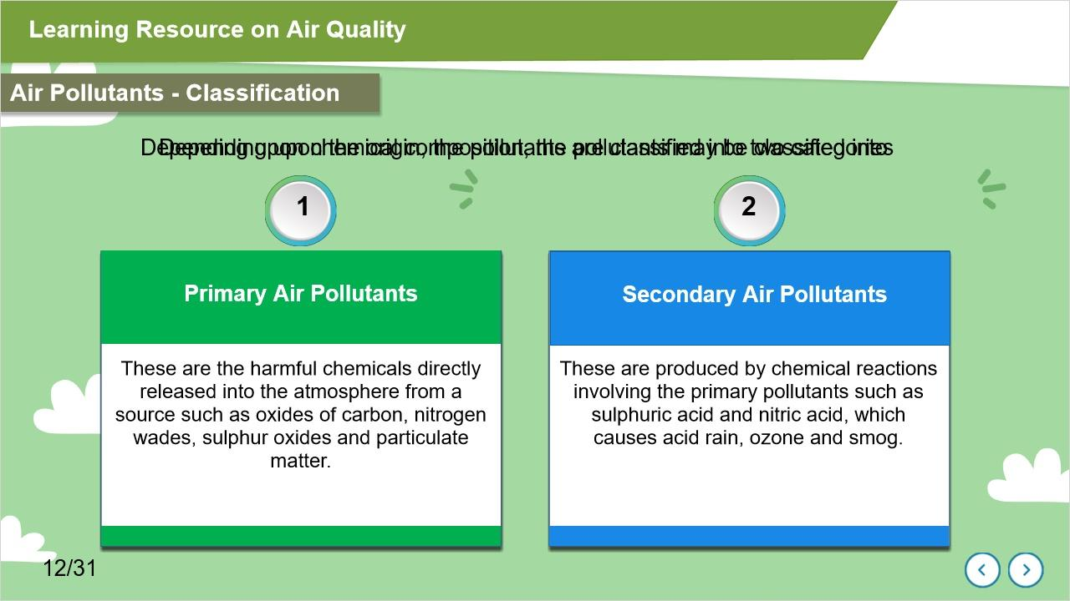
Notes:
Depending upon the origin, the pollutants are classified into human-made or anthropogenic pollutants and Natural Pollutants.
Depending upon the mobility of sources, pollutants can originate from Mobile and Stationary sources.
Depending upon their chemical composition, the pollutants may be classified into Primary Air Pollutants and Secondary Air Pollutants.

1.14 Here are some of the sources of air pollution
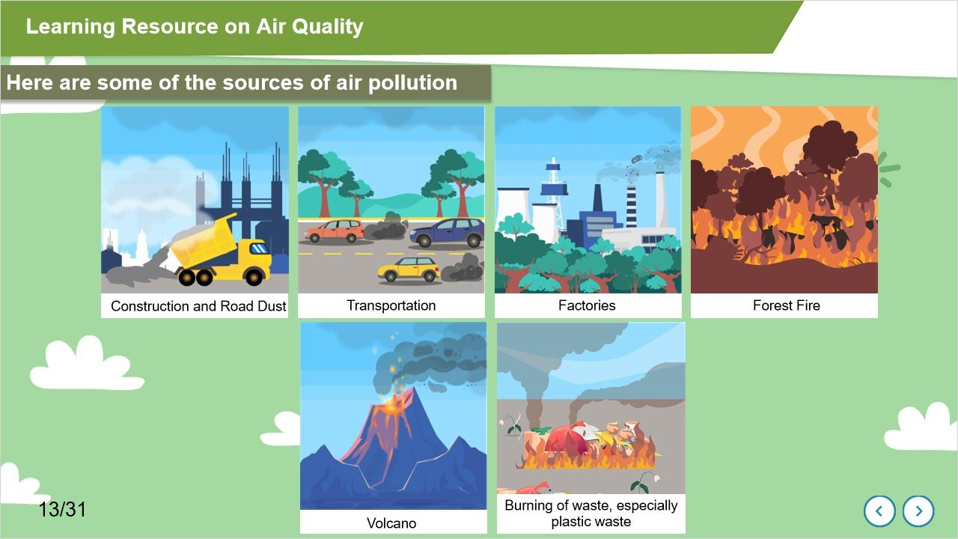
Notes:
Some of the sources of air pollution include - dust from construction sites, road dust, emissions from vehicles, unchecked emissions from factories, emissions from forest fires and volcanoes, and many more. These are just a few examples.

1.15 Causes of the pollutants
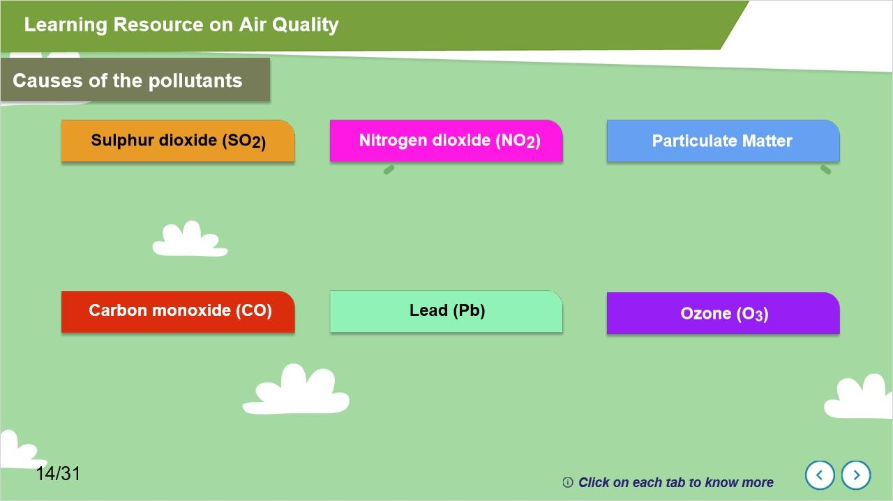
Notes:
Here are potential causes of some of the pollutants, for example
Coal and petroleum often contain sulfur compounds, and their combustion generates sulfur dioxide.
Nitrogen dioxide is expelled from high-temperature combustion. It is also produced during burning of fuels, and such other activities.
Particulate matter is a big challenge as it adversely affects our health. Particulate Matter includes dust, sulphate salts, heavy metal salts, fine particles of carbon or soot, silica, asbestos, and others. The smaller the size of the particle, the more easily it enters inside the human body and causes health effects.
Carbon monoxide is produced in the incomplete combustion of carbon-containing fuels, such as gasoline, natural gas, oil, coal, and wood.
Lead is emitted as aerosol predominately by the burning of solid fuel.
Ozone is created by chemical reactions between oxides of nitrogen and volatile organic compounds.

1.16 Indoor and Outdoor Air Pollution
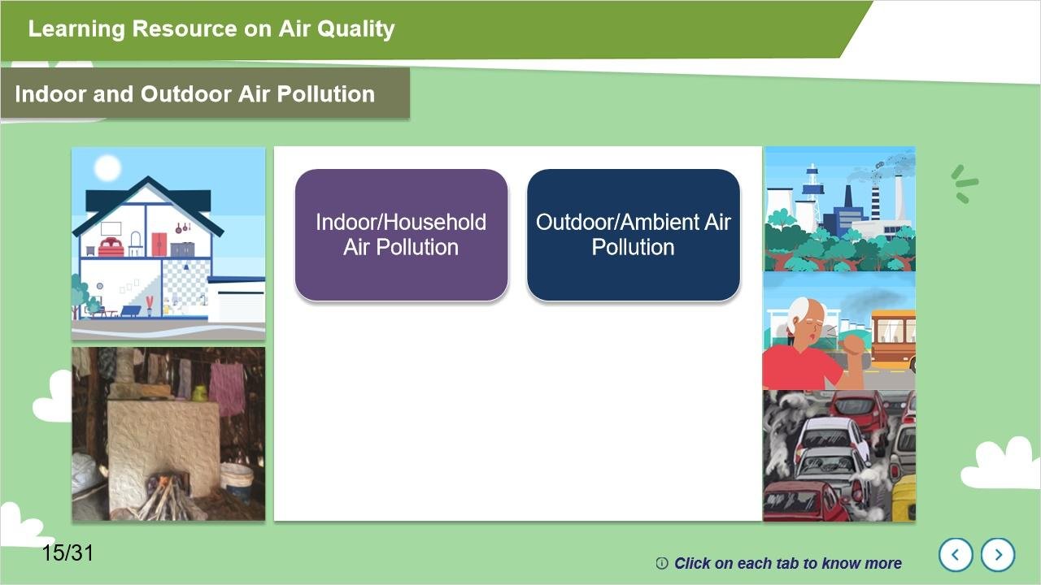
Notes:
We generally discuss about unchecked emissions from vehicles, factories and the burning of fossil fuels as causes of air pollution. But do you know that the air inside the home can also be polluted? For example, the smoke produced during cooking in our kitchen and the smoke from wood-burning chullahs are also sources of air pollution. In addition, dust, mites, and molds can also contribute to indoor air pollution.
Outdoor Air Pollution is also called Ambient air pollution and we are exposed to it during outdoor activities.

1.17 Introduction to Module 3
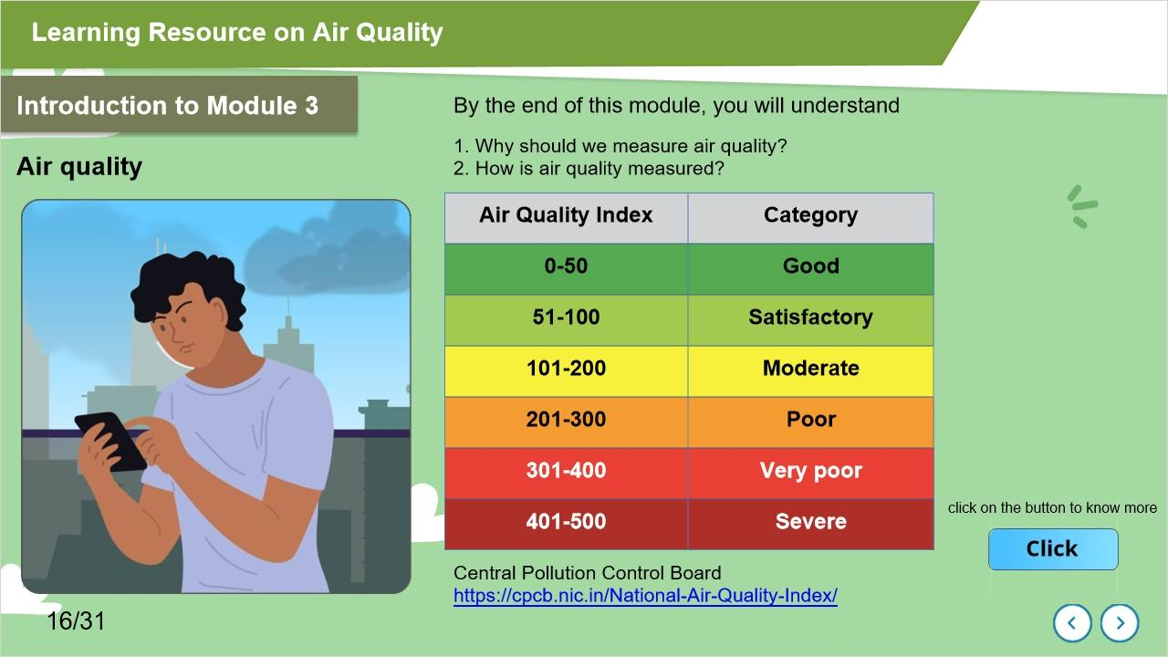
Notes:
Welcome to the third module; here, we will focus on Air Quality.
In this module, we will learn how air quality is measured and how we interpret Air Quality Index or AQI data.

click on the button to know more

Through its community science programme on air quality, Earthwatch Institute India is bringing together citizen scientists, air quality experts, scientists and medical professionals to promote science based public understanding about air quality and how to monitor air quality for educational purposes, using easy-to-use sensors and monitors.

1.18 Air Quality Index AQI
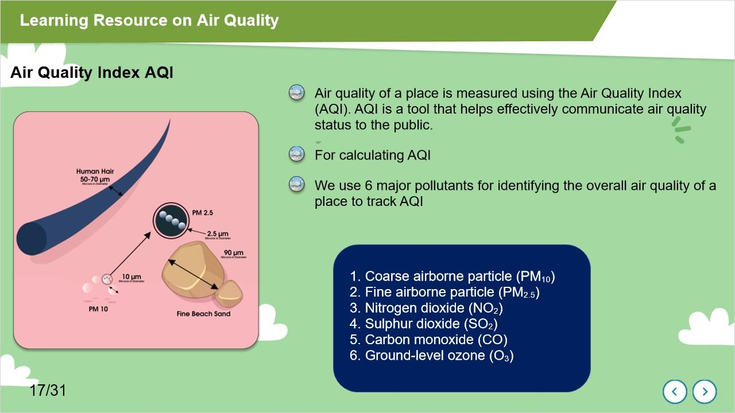
Notes:
In this module, we will learn how air quality of a place is measured using the Air Quality Index (AQI). AQI is a tool that helps effectively communicate air quality status to the public. For calculating AQI
We use 6 major pollutants for identifying the overall air quality of a place. Such as
1. Coarse air particles or Particulate Matter PM10
2. Fine air particle or Particulate Matter PM2.5
3. Nitrogen dioxide
4. Sulphur dioxide
5. Carbon monoxide
6. Ground-level ozone

1.19 Air Quality Index
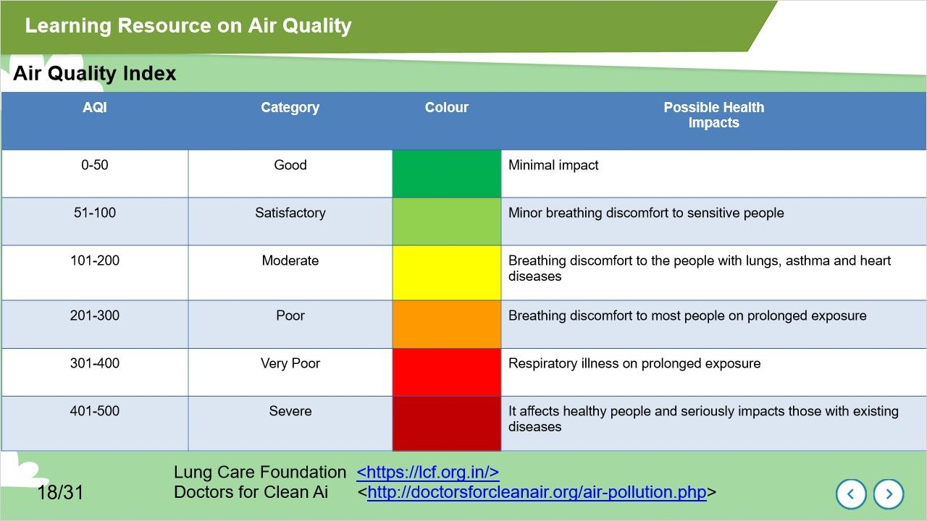
Notes:
Let's learn about the AQI Categories.

There are six AQI categories. Each category is based on ambient concentration values of air pollutants.
For example, an AQI between 0-50 is considered as good. At this low AQI level, a person can spend time outdoors, and air pollution will pose a minimal health risk. However, as the AQI number increases, the risk to human health also increases. For instance, AQI between 51 to 100 is satisfactory, between 101 to 200 is considered moderate, between 301 to 400 is poor, between 401 to 500 is considered severe.
As you can see, each category has a different colour coding.
Click on the Air Quality Index to know more

1.20 Why should we measure air quality?
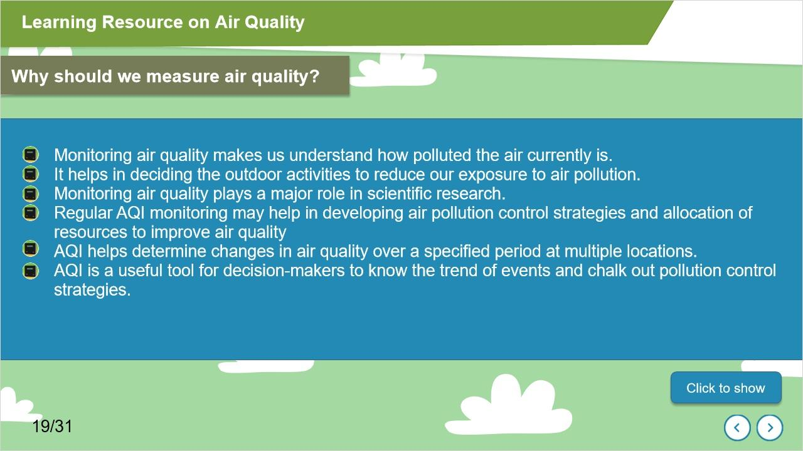
Notes:
It is important to understand the significance of measuring air quality using AQI, the Air Quality Index.
Monitoring air quality makes us understand how polluted the air currently is. It serves as useful information for people who suffer from illnesses aggravated or caused by air pollution to modify their daily activities when they are informed of pollution levels.
Regular AQI monitoring plays a major role in scientific research and education, and in developing strategies to improve air quality.
AQI is a useful tool to know the trend of events and to help plan pollution control strategies.

1.21 Introduction to Module 4
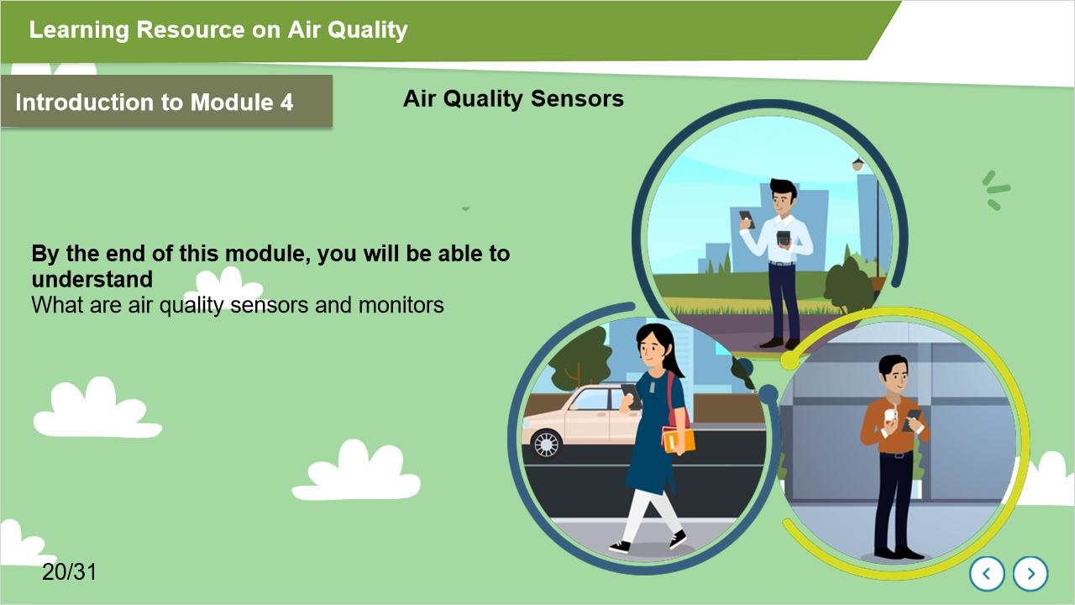
Notes:
Welcome to the Fourth module. Here you will learn about the importance of various air quality sensors.
You will learn about small and easy to use stationary, and mobile air quality sensors that you can use in your home, school, and residential area for real-time air quality monitoring.

1.22 What is a sensor?
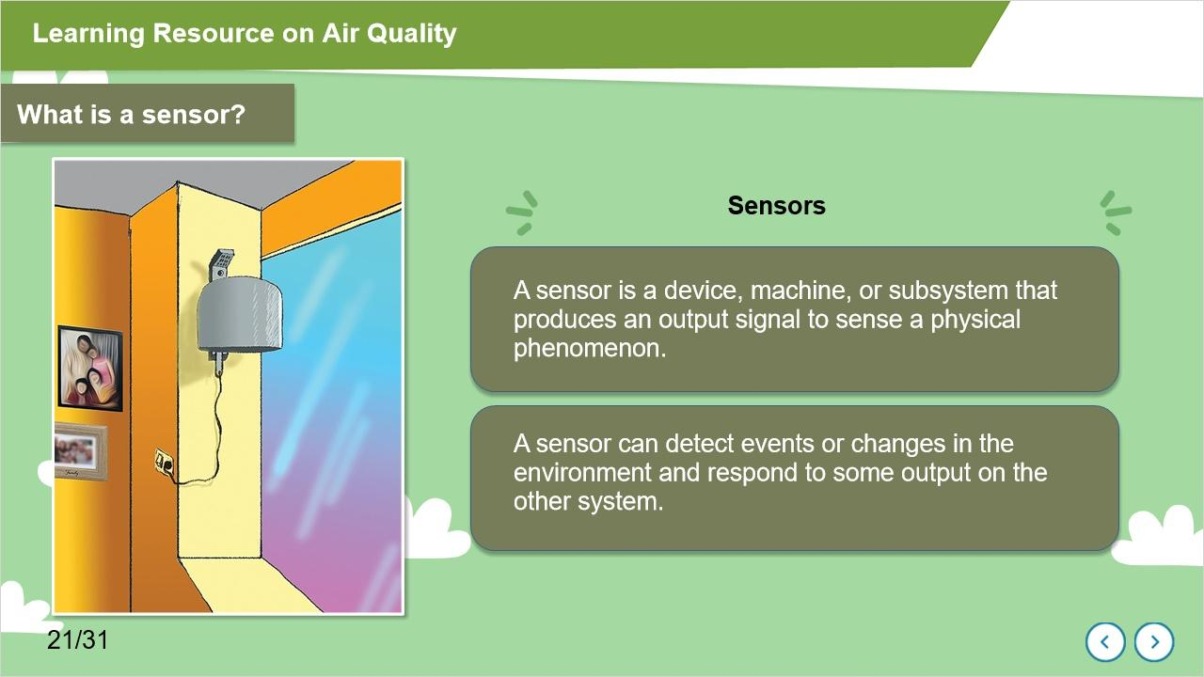
Notes:
A sensor is a device, machine, or subsystem that produces an output signal to sense a physical phenomenon.

A sensor can detect events or changes in the environment and respond to some output on the other system

1.23 Air Quality Sensors
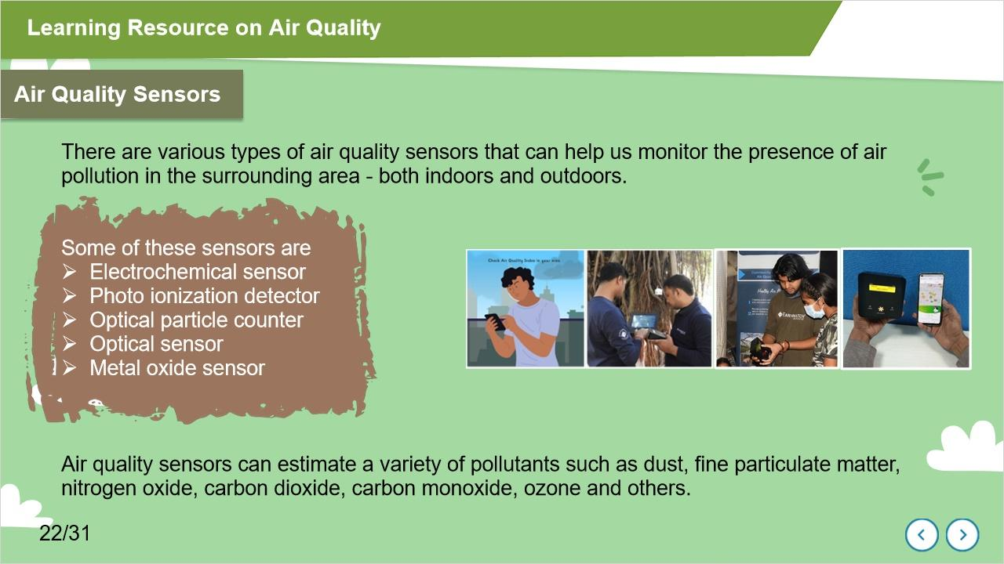
Notes:
There are various types of air quality sensors that can help us monitor the presence of air pollution in the surrounding area - both indoors and outdoors.
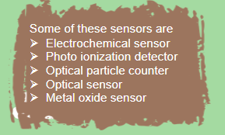
It can estimate a variety of pollutants such as dust, fine particulate matter, nitrogen oxide, carbon dioxide, carbon monoxide, and others.

1.24 Reference Grade Monitors
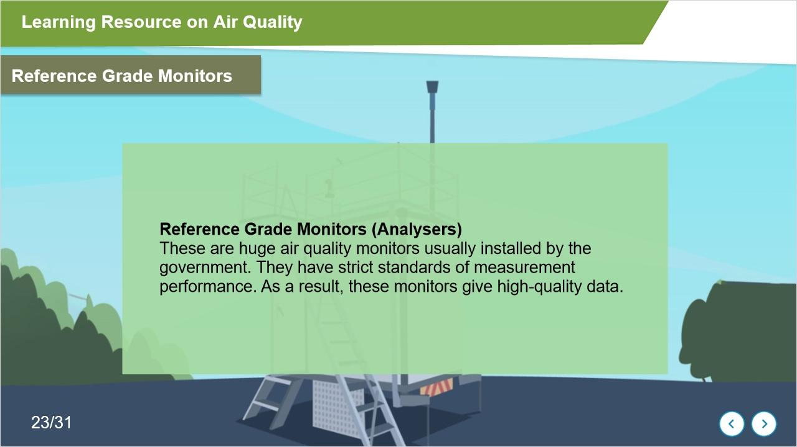
Notes:

The reference grade monitors are huge air quality monitors usually installed by the government.
They have strict standards of measurement performance. As a result, these monitors give high-quality data.

1.25 Introduction to Module 5
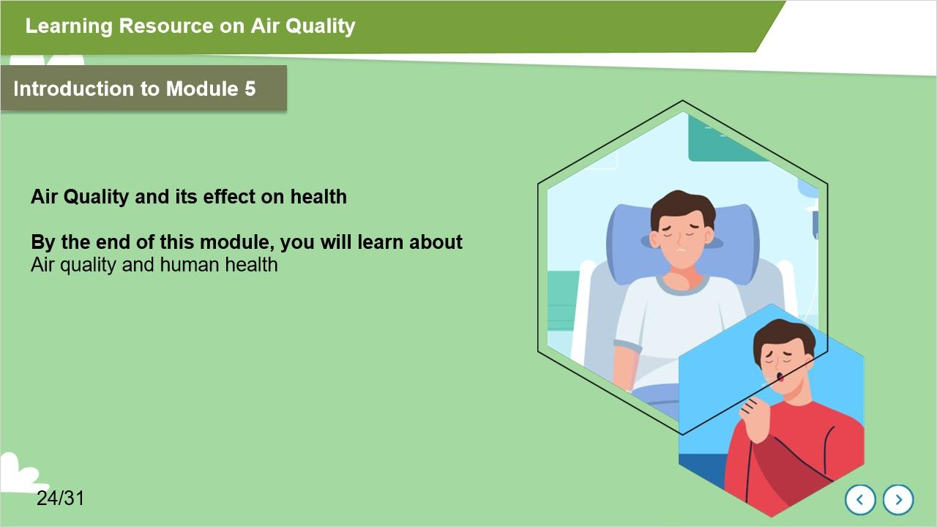
Notes:
Welcome to the 5th module.
Here, you will learn about the impact of air quality on human health

1.26 Air Quality and Human Health
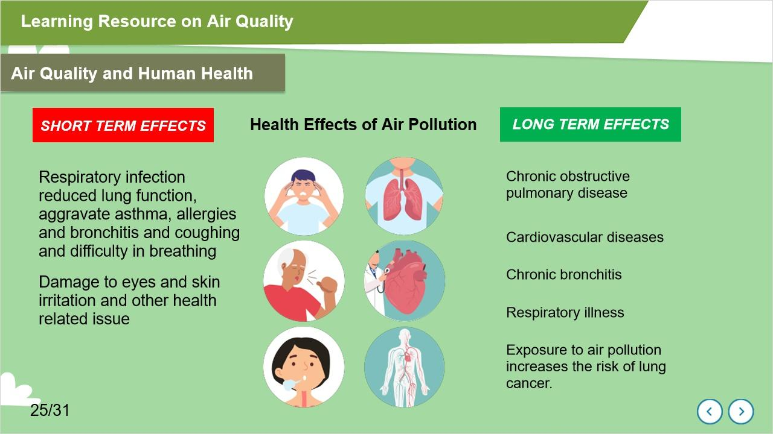
Notes:
Air pollution is a silent and invisible killer. Exposure to air pollutants can influence human health.

Short term effects include Respiratory infection, aggravate asthma, allergies and bronchitis, Damage to eyes and respiratory tract, skin irritation, coughing and difficulty in breathing

Long term effects include Chronic obstructive pulmonary disease, Cardiovascular diseases, Chronic bronchitis, Respiratory illness and Exposure to air pollution increases the risk of lung cancer.

1.27 Who is affected more by the harmful effects of air pollution?
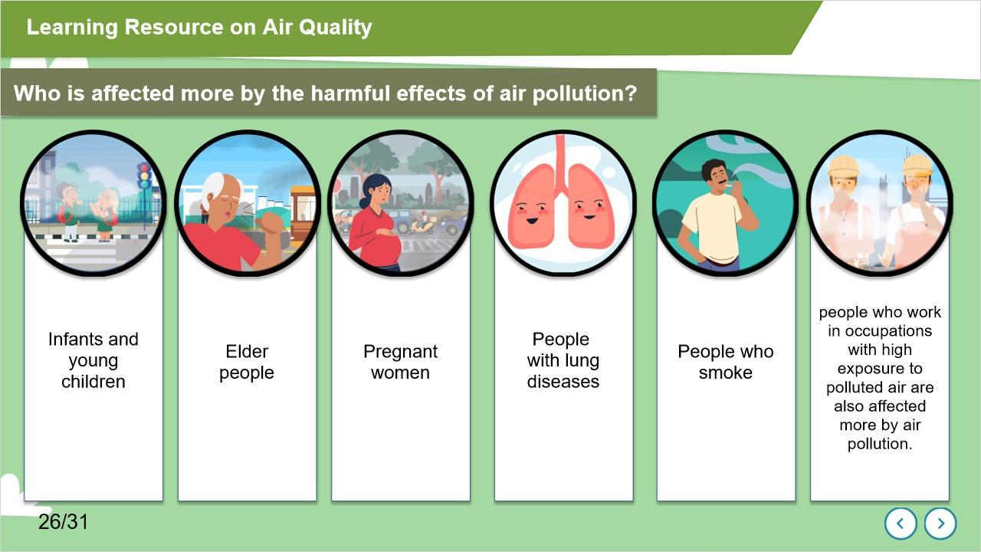
Notes:
Air pollution can affect all age groups. However, some people are more sensitive to air pollution.
Sensitive populations include children, older adults, pregnant women, people with lung diseases and cardiovascular diseases. In addition, people who work in occupations with high exposure to polluted air are also affected more by air pollution.

1.28 Introduction to Module 6
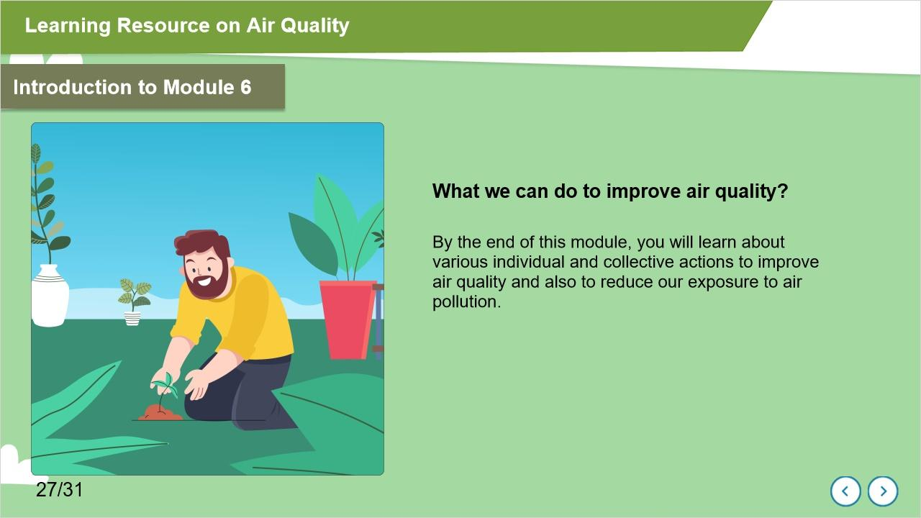
Notes:
Welcome to the Sixth module. Here we will discuss ‘What we can do to improve the air quality.’
Each one of us can help improve air quality. We all can make a positive difference by changing the way we travel, to the energy we use and the waste we generate.

1.29 Various individual and collective actions to improve air quality
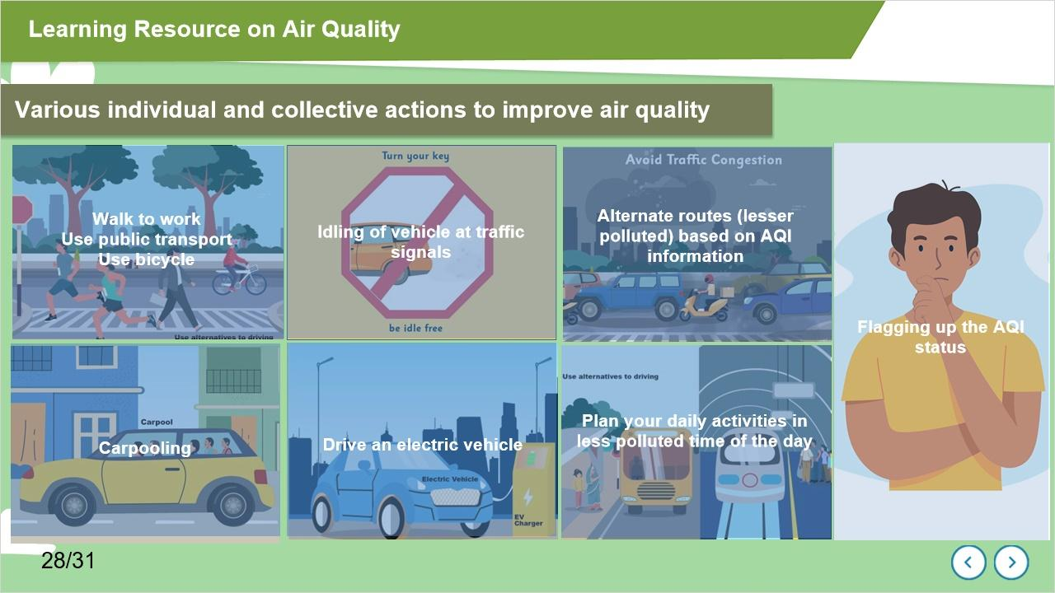
Notes:
Walking to work, greater utilization of public transport, using bicycles and encouraging carpooling can help in improving the air quality by reducing the number of vehicles on the road.
Idling vehicles while at traffic signals or being stuck in traffic jams causes wastage of fuel and results in the emission of pollutants. Practicing to switch off vehicles while in such situations leads to fuel-saving and reduction in vehicular emission.
Promoting electric vehicles and CNG vehicles also helps in reducing air pollution.
We can choose alternate routes which are less polluted based on AQI information. Commuters' exposure to air pollution can differ considerably depending upon the route taken. Based on the AQI information, commuters can choose which route to take. Therefore, Air Quality Index information can help commuters plan their traveling route and make informed decisions to reduce their exposure to air pollution.
We can plan educational initiatives in our school, based on the real time AQI. For example using a green flag for healthy air quality in our school educational programme and red for poor air quality. It can help guide students and teachers on whether or not to hold outdoor activities. We can plan our daily activities in a less polluted time of the day based on AQI and thus reduce our exposure to air pollution.

1.30 Various individual and collective actions to improve air quality
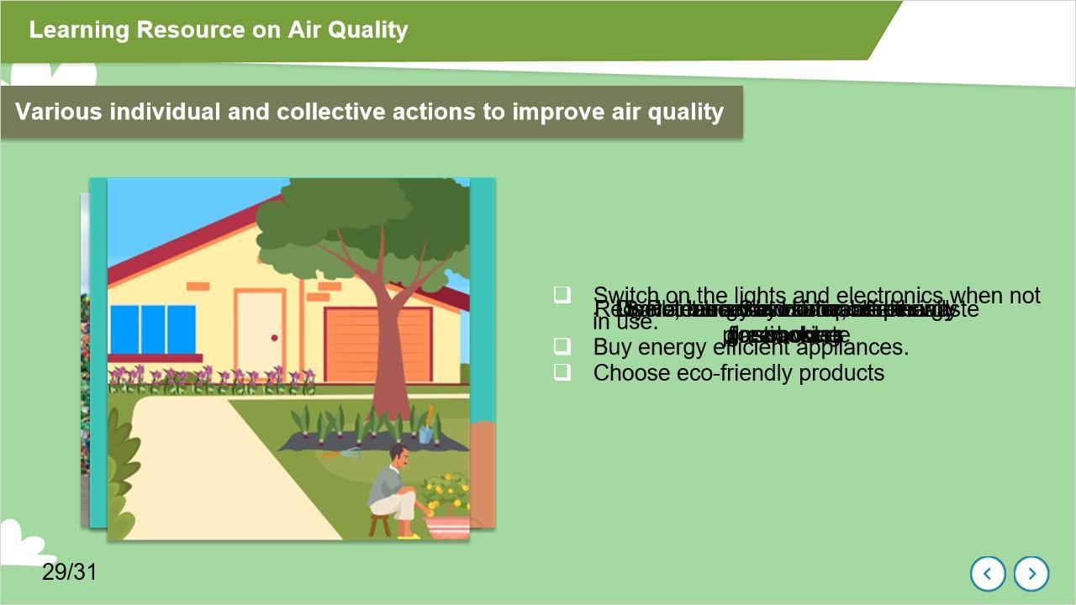
Notes:
Burning plastic waste releases harmful pollutants into the atmosphere. These pollutants cause long-term health impacts. Therefore, the burning of waste, especially plastic waste, in open spaces must be avoided, and improved waste management systems for collection, segregation, and recycling should be practiced.
We should also make efforts to save and conserve energy at our school, home and office. It helps reduce energy demand and consequent environmental impacts. For example, we can adopt energy-efficient technologies and devices, reduce usage and wastage of paper, use a reusable water bottle, promote solar energy, switch off the lights and electronics when not in use.
Purchase energy-efficient appliances and help save energy. Choose eco-friendly products.
Do not use firecrackers that release harmful pollutants into the atmosphere.
Recycle, reuse and compost the waste. It helps conserve resources and reduce pollution, and save energy.
The use of clean and sustainable energy sources for cooking helps in reducing indoor air pollution.
Plant more trees and increase the green cover. Trees can reduce the temperature by trapping heat and mitigating the greenhouse effect. Lower temperature decreases the need for air conditioning, reducing the energy demand that commonly spikes during summers.

1.31 Good practices across different strategic areas
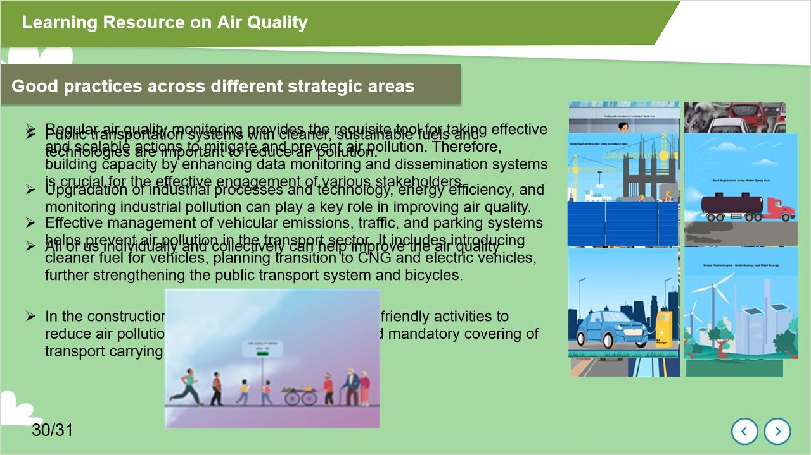
Notes:
Different sectors can promote good practices to improve air quality.
Starting with regular air quality monitoring provides the requisite tool for taking effective and scalable actions to mitigate and prevent air pollution and its impact on health. Therefore, building capacity by enhancing data monitoring and dissemination systems is helpful for the effective engagement of various stakeholders.
Effective management of vehicular emissions, traffic, and parking systems helps in improving air quality in the transport sector. It includes introducing cleaner fuel for vehicles, planning transition to CNG and electric vehicles, further strengthening the public transport system and bicycles.
In the construction sector, we can encourage eco-friendly activities to reduce air pollution and mitigate dust pollution and mandatory covering of transport carrying construction material.
Enhancing public transportation systems with cleaner, sustainable fuels and technologies and better services are important to reduce air pollution.
Upgradation of industrial processes and technology and promoting energy efficiency can play a key role in improving air quality.
All of us individually and collectively can help improve the air quality

1.32 Good practices across different strategic areas

Notes:

