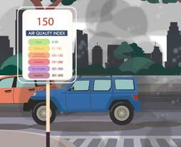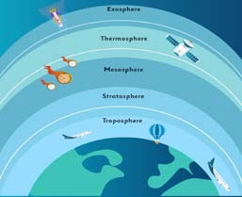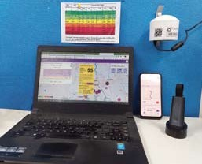

Learning Module on Air Quality
Clean air begins with me

Atmosphere Pollution Air Quality

Sensors Human Health Solutions

Understanding air pollution and what we can do to improve air quality

Air Pollution Online Learning Modules

Atmosphere

1

Air Pollution

2

Air Quality

3

Air Quality Sensors

4

Air Pollution and Human Health
5

Solutions and Innovations
6

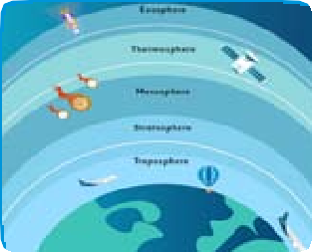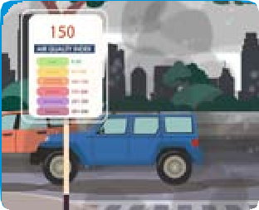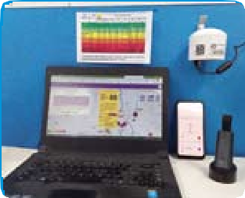

Clean air begins with me

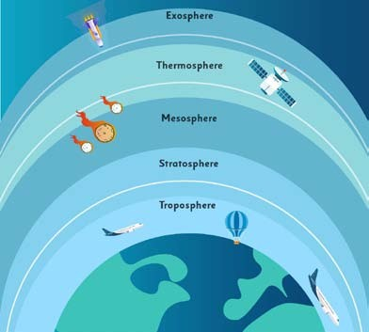
Learning Module

1

ATMOSPHERE

An Overview

Learning Themes

Understanding the atmosphere
- Composition of the air
- Significance of the air

Learning Objective

Know about the composition of air, layers of the atmosphere
- The role that air plays in the planet, and its functions

Evidence of Leaning

Self-evaluating quiz on composition, properties and functions of air and atmosphere.
- Appreciation of the role that healthy air plays in our life

Supporting Information

Experiment on oxygen in the air
- Experiment on water vapour in the air

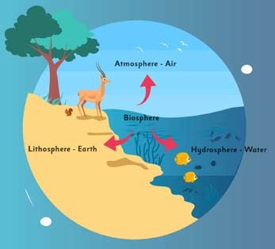
The atmosphere is a mixture of various gases, water vapours, and particles surrounding Earth. We cannot imagine our life without the presence of the atmosphere.
Gases
Atmosphere
Water Vapor
Dust Particles
The layer of gases, commonly known as air, is the Earth’s atmosphere; it is held around the planet by its gravity. Air also carries soot, smoke, and other particles from
car exhaust and power plants. These are major contributors to air pollution also.
What is Atmosphere?
it is essential to understand the structure and composition of these spheres. In this module, we are
discussing atmosphere.

Earth is the only planet in the universe where life exists in all its variety. From what we know of our universe Earth system can be broadly recognized as different spheres, like the Lithosphere, Hydrosphere, Atmosphere, and Biosphere.
Our life on the Earth is possible only due to the presence of these spheres. That is why


Aerosol is a kind of heterogeneous mixture -
see different classifications of mixtures here
Matter
Mixture
Heterogenous
Suspensions
Colloids
Emulsion Eg-Milk
Foam Eg- Whipped Cream

99% of Earth’s air is primarily composed of two main gases, nitrogen (about 78%) and oxygen (about 21%). Other gases are argon (about 0.9%), carbon dioxide (0.04%) and remaining gases in trace amounts.
There is also the presence of water vapour in the atmosphere, whose amount significantly varies from time to time.
There are also many small particles that are solid, liquid, and gaseous in nature, called “aerosols,” including dust, spores and pollen, salt from sea spray, volcanic ash, smoke, and more.

Oxygen, 21%

Carbon dioxide, 0.04%
Argon, 0.90%
Trace Gases, 0.0600%

Nitrogen, 78%
Composition of Air
Gel Eg-Jam, Cheese

Solutions

Homogenous

Elements

Compound

Pure Substance
Aerosol Eg-Fog, hairspray
Sol Eg-Blood, Ink, Paint

Alloys

Here is an experiment to show that oxygen is a component of the air
Experiment time – Air has 1/5th of oxygen

- Take a tumbler
- Fix a candle in the center with some wax
- Add some water to the container
- Light the candle
- Take a transparent cylindrical gas jar and invert it over the candle

Explanation
- Any flame requires three ingredients: oxygen, fuel, and heat.
- Fuel is the wax of the candle.
- You gave heat to the wick with the help of a matchstick
- When not in the gas jar the candle is using oxygen in the atmosphere.
- The water rises inside the gas jar 1/5 th of the total volume indicating that 1/5th of atmosphere has oxygen

Precaution - Don’t play with fire, do this under adult supervision

Air also carries soot, smoke, and other particles from various sources (for example emission from vehicles, factories etc). These are major contributors to air pollution.
The air has water vapour in it. Relative humidity is the amount of water the air can hold. It is usually measured in percentages, so the highest level of relative humidity—right before it rains—is 100 percent.

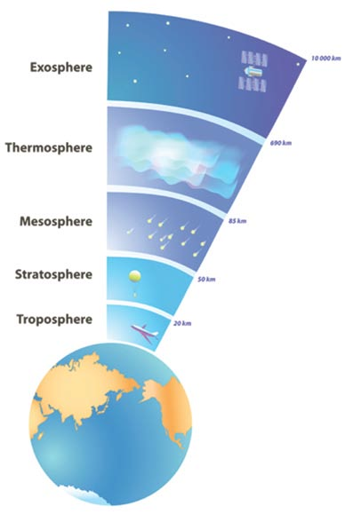Layers of Atmosphere

Our atmosphere is classified into five main layers- Troposphere, Stratosphere, Mesosphere, Thermosphere, and Exosphere, as shown here.

- Troposphere: The troposphere is the lowest layer of our atmosphere, and nearly 75-80% mass of the atmosphere is composed of the troposphere. From the Earth’s surface, this layer extends in an upwards direction nearly 10 km above sea level. The altitude of this layer varies from 16 km at the equator to 8 km at the poles. All life exists in this layer. We human beings also live in this layer. Since approximately 99% of the water vapours are present in the troposphere, hence most clouds are visible in this layer. Almost all-weather conditions have occurred in this layer.

- Stratosphere: Just after finishing the troposphere layer, the stratosphere comes into existence. The boundary which separates the troposphere and stratosphere is known as Tropopause. From the troposphere, the stratosphere is nearly 50 km high. The ozone layer is also found within this layer, which absorbs high-energy ultraviolet (UV) light from the Sun, converting the UV energy into heat. In the lower stratosphere, jets for commercial passengers generally fly due to less turbulence.

- Mesosphere: The layer just above the stratosphere is known as the mesosphere. The mesosphere goes up to 85km above the surface of Earth. The variation in temperature for this layer is similar to the stratosphere. The higher we go, the colder it will be, i.e., with an increase in altitude, the temperature will decrease. In this layer, the oxygen level is so low that it would be very difficult to breathe. So, in essence, the higher you go, the colder it gets. Also, this layer of the atmosphere has the lowest temperature of all layers, and they drop down to -90° C.

- Thermosphere: Thermosphere is situated between 500-1000 km above ground level. It is the layer after the mesosphere. As the name suggests, this layer has the highest temperature. Therefore, x rays and Ultraviolet radiations of the Sun always attack this layer due to which temperature of this layer can even reach 2,000° C!

- Exosphere: It is the outermost layer of our planet. It is difficult to distinguish how far the exosphere is from the surface of the planet, but somewhere it is nearly 100,000 km but may expand up to 190,000 km above sea level. It is very low in density. The atoms like hydrogen and helium are present in this layer in abundance.


Air is an essential element in human survival. An adult breathes 15,000 litres of air every day. Impure air affects our health and other organisms present on planet Earth.
Significance of the Air

- Oxygen is used by most organisms for respiration.
Do you know?
Breathing and Respiration are two different processes. Breathing is the physical process of exchanging gases, while respiration is a chemical process that happens at cell level, and produce energy.

- Nitrogen is fixed by bacteria and lightning to produce ammonia.
Do you know?
Nitrogen fixation is the chemical process by which molecular nitrogen which is plentily available in the atmosphere is converted to ammonia or related nitrogenous compounds.

- Carbon dioxide used by plants, algae etc. for photosynthesis, also high levels of carbon dioxide in air result in increasing earth’s temperature and creates global warming.

- Air creates pressure which allows liquid water to exist on the Earth’s surface.

- Air reduces temperature extremes between day and night (the diurnal temperature variations).

- Air protect us from meteoroids. When meteoroids contact our atmosphere, they rub against the air and often are burned into small pieces before reaching Earth.

- Ozone, a type of gas in the air, protects us from too much sunlight and ultraviolet radiation. There is also bad ground level ozone which is harmful for human health, we will learn more about this in the coming chapters.

Question 1. What is the atmosphere? Question 4. What does the ozone layer do?
A A layer of fluids surrounding an object.
A It protects us from meteors.

B A layer of gas surrounding a planet or moon.
B It protects us from violent solar flares.

C A cloud of gas that allows us to breathe.
C It protects us from ultra violet radiation.

D A layer of oxygen that surrounds a planet or moon.
D It helps us breathe.

Question 2. Which gas makes up around 21% of our atmosphere? Question 5. The five layers of atmosphere from top to down are?
A Methane
A Exosphere, Mesosphere, Thermosphere, Troposphere, Stratosphere

B Oxygen
B Exosphere, Thermosphere, Mesosphere, Stratosphere, Troposphere

C Nitrogen
C Mesosphere, Thermosphere, Exosphere, Stratosphere, Troposphere

D Carbon dioxide
D Thermosphere, Exosphere, Mesosphere, Troposphere, Stratosphere

Question 3. What layer does most weather occur in?
A Troposphere

B Stratosphere

C Thermosphere

D Mesosphere

Can you also please mention about the significance of the atmosphere?



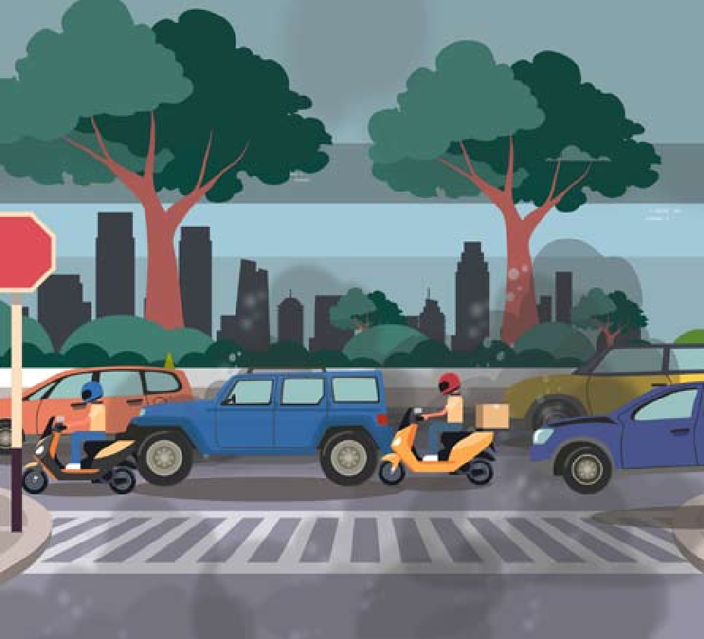
Learning Module

2

POLLUTION

An Overview

Learning Themes

Understanding air pollution
  - Causes and sources of air pollution

Learning Objective

Understanding various pollution sources
- Understanding indoor and outdoor air quality parameters

Evidence of Leaning

Appreciation about the fact that pollution is existent/real
- Believe that as individuals, we should take positive actions to reduce pollution, and these can bring some changes

Self-evaluating quiz on pollution sources and causes.
- Informed decision making (empowerment of citizens with science and data)

Supporting Information
1. Experiment on water vapour in the air

Pollution

The introduction of harmful and undesirable materials/chemicals into the environment is known as pollution. These harmful materials/chemicals are called pollutants. Pollution results in changing the quality of the environment. Pollution is a global problem and damages the quality of air, water, and land. Urban areas seem to be more polluted as compared to rural areas. The leading causes of pollution in urban areas include unplanned urbanization, increased number of vehicles, and lifestyle patterns.

Land Pollution
Water Pollution
Sound Pollution

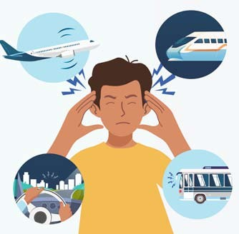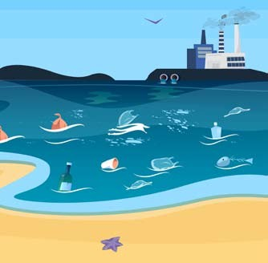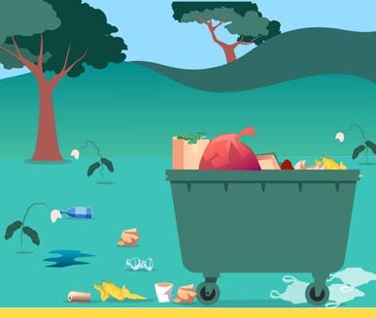Land Pollution - is the deposition of solid or liquid waste materials on land or underground in a manner that can contaminate the soil and groundwater, threaten public health, and cause unsightly conditions and nuisances.
Water Pollution – is the release of substances into water bodies like lakes, rivers etc. and affect the beneficial use of the water (drinking, cooking etc.) or the natural functioning of ecosystems.

Types of pollution
Sound Pollution - is the unwanted or excessive sound that can have deleterious effects on human health, wildlife, and environmental quality.

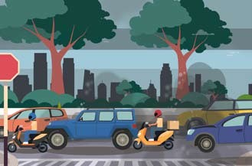
Air Pollution
Air Pollution – is the of various gases, finely divided solids, or finely dispersed liquid aerosols into the atmosphere at rates that exceed the natural capacity of the environment
to dissipate and dilute or absorb

The presence of air pollutants such as chemicals, particles, and toxic compounds makes the air polluted. These air pollutants are present in various forms like solid particles, liquid droplets, and gases. Air pollution can cause health problems, including respiratory diseases such as bronchitis and asthma. It can cause wheezing, dry throat, headache, nausea, and other diseases.
Air Pollution

Air Pollutants
Air pollutants can be found anywhere, in outdoor air, vehicles, buildings, parks, industries, etc. These are broadly classified into three main categories:

Type of Air Pollutants

Criteria pollutants
These pollutants are considered an indicator of air quality. Some of the criteria air pollutants are:
- Carbon monoxide
- Lead
- Nitrogen dioxide
- Ground-level ozone
- Particulate Matter
- Sulfur dioxide

1

Criteria Pollutants
2

Air Toxics
3

Biological Pollutants
There are also non-criteria air pollutants that are less prevalent in the atmosphere.

- Air toxics
These are also called hazardous air pollutants due to their high adverse effects on human health. It includes organic compounds such as volatile organic compounds, polycyclic aromatic hydrocarbons. If air toxics were inhaled in high amounts, it might cause serious ailments.

Biological pollutants
In the air, there is some microbial and biological contamination as well, e.g. the skins and cells of humans and animals, molds, and waste of animals and insects. Studies have shown that biological pollutants, also known as bioaerosols, are mainly found in indoor air.

Types of Air Pollution

With the increase in population, the demand for resources has increased. The lifestyle pattern has also changed, which results in the deterioration of the quality of the environment. The growth of vehicles, unplanned urbanization, construction activities, biomass and coal burning, road dust and smoke are the main factors for poor air quality.

Depending upon the origin, the pollutants are classified into two categories:
Depending upon the mobility of sources, pollutants can originate from:

1 2 1 2

Human-made (Anthropogenic) pollutants:

These pollutants come from human activities such as burning fuels and wood, emissions from vehicles and industry, and many more.
Natural Pollutants

These sources come from natural activities such as wildfires, volcanoes, etc.
Mobile Sources

Sources that are moving in nature, i.e., from one place to another, such as vehicles.
Stationary Sources

Sources that are non-moving in nature and placed at one particular point, such as factories, refineries etc.

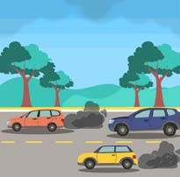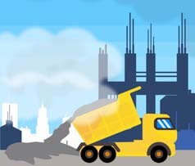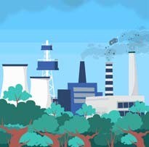
Construction and Road Dust

Transportation

Factories Forest Fire Volcano

Sources of air pollution


Experiment time – Air has water vapor

- Light a candle
- Take a can and hold it with an insulated holder over the candle flame for few seconds – such that the top of flame touches the surface of the can

What do you observe?
The black soot accumulated is the evidence of pollution. This soot is formed because of incomplete combustion. The fuel in candle (the wax) is not completely burnt – the left overs are called byproducts of combustion – like CO2 (we can’t see) and soot (which is collected on the surface of the can)
Depending upon their chemical composition, the pollutants may be classified into :
1
2
Primary Air Pollutants
Secondary Air Pollutants
These are the harmful chemicals directly released into the atmosphere from a source such as oxides of carbon, nitrogen oxides, sulphur oxides and
particulate matter.
These are produced by chemical reactions involving the primary pollutants such as sulphuric acid and nitric acid, which causes
acid rain, ozone and smog.
Depending upon the type of sources, pollutants are classified into two categories:
1
2
Point Sources Pollutants
Non-Point Sources Pollutants
They derive from sources that are stationary in nature and release a large number of pollutants in a concentrated manner—for example, oil refineries, industries, sewage
treatment plants, paper mills etc.
They derive from mobile sources which release pollutants in a diffused manner – for example, burning of garbage, stubble burning, emissions
from vehicles, emissions from
aeroplanes etc.

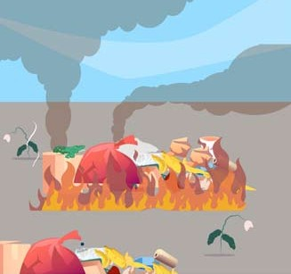

Potential Causes of some of the pollutants
- Sulphur dioxide (SO₂) - Coal and petroleum often contain sulfur compounds, and their combustion generates sulfur dioxide. Other causes are refining, paper manufacturing; municipal incinerating; ore smelting for metal extraction.
- Nitrogen dioxide (NO₂) - is expelled from high-temperature combustion. It is also produced during thunderstorms by electric discharge. Other sources are the burning of fuels, biomass burning, and a by-product in the manufacturing of fertilizers.
- Particulate Matter (PM) - includes dust, soil, sulphate salts, heavy metal salts, fire particles of carbon (soot), silica, asbestos, liquid sprays, mist, etc. These mainly come from fuel combustion, building constructions, mining, thermal power stations, stone crushing, industrial processes, forest fires and refuse incineration. Particulate matter is a big challenge as it adversely affects our health. The smaller the size of the particle, the more is the health effects. Increased levels of fine particles in the air are linked to serious health ailments such as heart disease, altered lung function, and other diseases.
- Carbon monoxide (CO) - is a colorless, odorless, tasteless, and toxic air pollutant—is produced in the incomplete combustion of carbon-containing fuels, such as gasoline, natural gas, oil, coal, and wood.
- Lead (Pb) - Lead can remain in the environment as dust indefinitely as it is non bio-degradable. Lead in the air is emitted as aerosol predominately by burning of solid fuel (i.e. coal and biomass).
- Ozone (O₃) - Ozone occurs both in the Earth’s upper atmosphere (good ozone, as it protects us from Sun’s harmful UV rays) and at ground leve (bad ozone). Tropospheric, or ground level ozone, is not emitted directly into the air, but is created by chemical reactions between oxides of nitrogen (NOx) and volatile organic compounds (VOC). This happens when pollutants emitted by cars, power plants, industrial boilers, refineries, chemical plants, and other sources chemically react in the presence of sunlight.

Indoor and Outdoor Air Pollution

We generally discuss emissions from vehicles and industries and the burning of fossil fuels as causes of air pollution. But do you know that the air inside the home is also polluted? There are repellants, toilet cleaners, printing machines, radioactive materials, chulhas smoking and many more in our house, which make our indoor air unhealthy.

So broadly, the type of air pollution is classified into two major categories:
- Indoor/Household Air Pollution
- Outdoor/Ambient Air Pollution

Indoor Air Pollution
is also known as household air pollution. When our inner house,

Pets Mold

working area, or buildings are contaminated or polluted, it is known as indoor pollution. Dust, molds, cook stoves, cooking fuel and smoke are the main contributors to indoor

Dust mites
Animal Hair
& Dander
Molds & Bacteria

Pollen

Carpets and Upholstery

air pollution. In many studies, it has been observed that women and
Food Tobacco

children live in their homes most of the time, so they are at more risk by
Pesticide and Fumes
From Chemicals
Smoke Contains
3,000 Chemicals

indoor air pollution.
Chemicals Mildew

Damp Basements


Outdoor Air Pollution
is also called Ambient air pollution. An increase in population and their demands, emissions from vehicles, emissions from factories and industries, burning of coal, biomass/stubble burning, and dust particles from construction activities are major sources of outdoor air pollution. Studies have shown that many premature deaths occur every year due to outdoor air pollution. In outdoor air, particulate matter is present in more amounts and is harmful to human health. We are exposed to air pollution during jogging, walking and going to schools, colleges, offices, and markets and during any other outdoor activities. Many studies have observed that outdoor air is poorer during traffic hours, so we should avoid outdoor activities during that time to prevent our health from the harmful effects of air pollution.

Smog

The presence of pollutants in air which reduces the visibility is known as smog. The word “smog” consists of two words smoke and fog to refer to smoky fog due to its opacity, and odour.
Smog is the result of the reaction of emissions from automobiles, factories, and industries with the sunlight and atmosphere. Depending upon the type of pollutants and chemical reaction, smog is classified into two categories:

Smog
Industrial/Sulphurous Smog Photochemical Smog

1

Industrial/

2

Photochemical/
This type of smog was first observed in London in1952.
It is formed due to sulphur dioxide (SO2) and humidity in the air, which combines to form Sulphuric Acid (H2SO4) fog that gets deposited on the particulate.
This type of smog was first observed in Los Angeles in1950.
It is formed due to a photochemical reaction when the air contains NO2 and hydrocarbons.

Sulfurous/
Los Angeles
It involves smoke and fog. It does not involve any smoke and fog.

London Smog
Smog
It is formed in winter, particularly in the morning hours, when the temperature is low.
It is formed in summer during the afternoon when there is bright light so that a photochemical reaction can occur.

It causes problems in the lungs. It causes irritation in the eyes.

Tyndall Effect
The Tyndall effect or the Tyndall phenomenon is the scattering of a beam of light by a medium containing small suspended particles such as smoke or dust in a room, making a visible light beam entering a window.

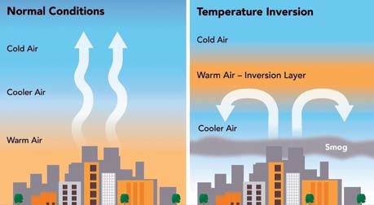Temperature Inversion

Generally, temperature decreases with increasing height, known as Normal Lapse Rate, but at times instead of this, the temperature increases for a certain distance characterized by a negative lapse rate. When temperature increases with increasing height, this condition is known as Temperature Inversion.
One type of temperature inversion is ground inversion/radiation inversion. It occurs near the ground due to the cooling of the earth by radiation, so also called radiation inversion. It usually occurs in the winter season in the lower and middle latitudes, while it occurs throughout the year in Polar Regions. This is because the air which comes in immediate contact with the cold ground surface becomes cool. In contrast, the upper air remains warm, resulting in colder air near the ground and warmer air above - causing temperature inversion.

Fogs are formed due to temperature inversion. Fogs mix with smoke to form a toxic mixture known as smog. Smog has become a regular feature in cities. Smog hinders navigation and communication thereby resulting in accidents.

Suggestive activity

Can you enlist some of the potential sources of air pollution in your area along with the category of air pollutants that they belong to?

150

Learning Module

3

AIR QUALITY

An Overview

Learning Themes

Why should we measure air quality?
  - How is air quality measured?

Learning Objective

Through community science programme on air quality, develop public understanding about pollution based on science

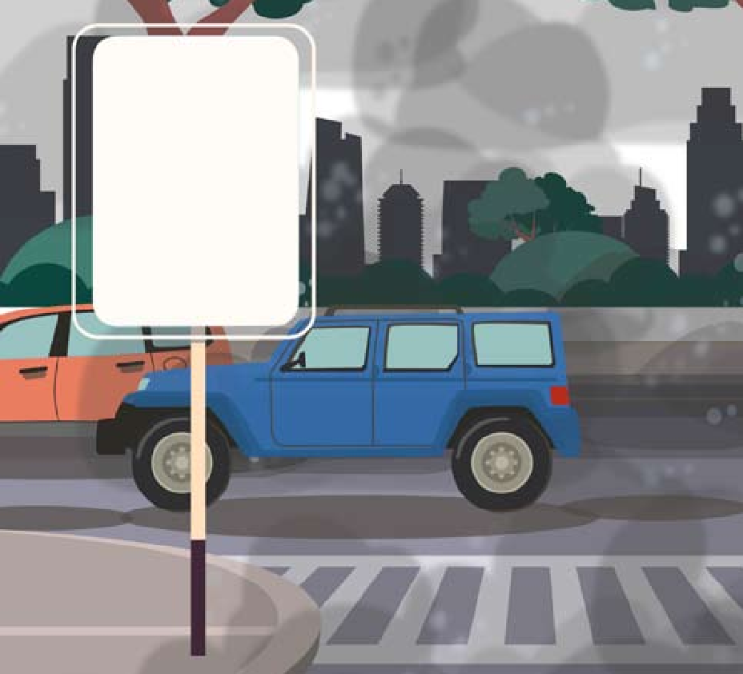 Air Quality Index

Good | 0-50
Satisfactory | 51-100
Moderately polluted | 101-200
Poor | 201-300
Very Poor | 301-400
Severe | 401-500

How do you know the air is polluted, and to what extent?
- Reduce exposure to pollution while planning daily activities by taking precautionary measures

Evidence of Leaning

Develop interest in monitoring air quality data
- Should be able to understand the Air Quality Index

The air free from any contamination/pollution is known as healthy air. You can classify the air into the healthy category if-
1
2
3
4
5
6
The air is free of air pollutants
The air seems to be fresh and clean
The air makes you feel happy and energized
The sky appears to be clear blue
The visibility is clear up to a longer distance
You are not feeling any discomfort in breathing

Why air Pollution?
- Increase in population with increased demand for resources, rapid urbanization and deforestation - all these factors impact air quality.
- 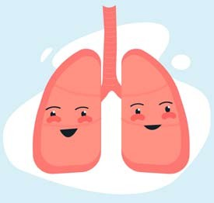Outdoor air pollution is a concern for many cities. It arises from a wide variety of sources such as motor vehicles, various manufacturing processes, residential fuel usage, biomass burning and road dust.
- The vehicular traffic-generated pollutants include nitrogen oxides (NO_{x}), carbon monoxide (CO), volatile organic compounds (VOCs) and particulate matter (PM).
- A mix of nitrogen oxides and volatile organic compounds emissions, combined with strong sunlight during the day, leads to a buildup of ozone (O₃).
- Growing levels of urbanization have generally resulted in increased air pollution. This is due to higher transportation and energy demand activities. Particulate matter is the primary concern due to its direct linkage to human health, such as chronic and acute respiratory diseases and other ailments.
For more information on air pollution and health please look up Module 5.

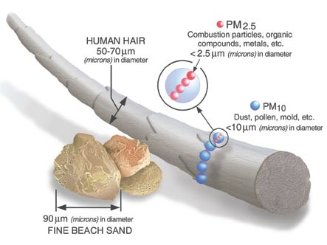Significance of Particulate Matter (PM) in Air Quality Index (AQI)

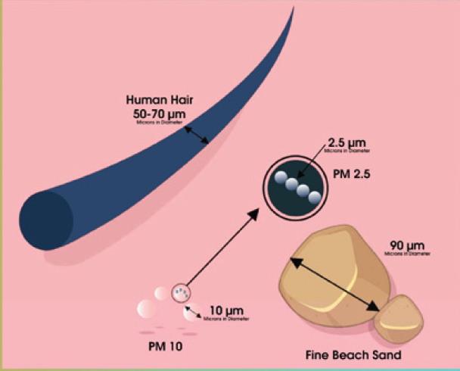
The particles that are suspended in the air are classified by size i.e. aerodynamic diameter and chemical composition.
- Particulate matter is measured in terms of the mass concentration of particles within
certain size such as:
  - PM₁₀ (Aerodynamic diameter of less than 10 μm. It is referred to as coarse)
  - PM_{2.5} (Aerodynamic diameter of less than 2.5 μm. It is referred to as fine)
  - Ultrafine PM (those with a diameter of less than 0.1 micron)

The coarse and fine particles come from different sources or formation mechanisms and this leads to variation in their composition and properties.
The range of sizes affects the atmospheric lifetime, spatial distribution, indoor- outdoor ratios and health impacts of the particles.
The lifetime of the particles varies because of their size and shape. For example, the coarse particles have an average lifetime between minutes to hours. In contrast, the fine particles average between days to weeks. The travel distances for coarse particles range from 1 to 10s of kilometres, and the fine particles average from 100s to 1000s of kilometres.

These particles occur naturally, originating from dust storms, forest fires, living vegetation and volcanoes. Some exist due to human activities, such as fossil fuel combustion, industrial emissions, and land-use change.
Particulate Matter is classified as primary and secondary particles:
- Primary particles are emitted directly into the atmosphere from various sources such as road traffic, road dust, industrial activities, burning and windblown soil.
They are composed of carbon and organic compounds, metals and metal oxides, and ions.
- Secondary particles are formed through the chemical transformation of the gaseous. Examples - Sulfur Dioxide (SO2), Nitrogen Oxides (NO_{x}), certain Volatile Organic Compounds (VOCs).

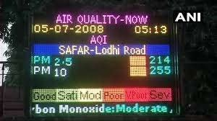Common Particulate Matter (PM) Sizes

The particulate matter pollution is measured as a single entity. However, the composition of particulate matter pollution is complex.
- It consists of primary pollution from direct sources. These include

PM10 PM2.5 PM1 UFP

vehicle exhaust and industries flue gases.
- The secondary pollution includes chemical transformation of other pollutants into aerosol forms such as sulfur dioxide to sulfates, nitrogen oxides to nitrates, and volatile organic compounds to secondary organic aerosols.
- Therefore, a common denominator called the Air Quality Index provides a common platform to compare and assess the impact of various pollutants together.
all particles with aerodynamic diameter
<10 micro-meter

most commonly measured size fraction
all particles with aerodynamic diameter
<2.5 micro-meter

size fraction linked to various health impacts
all particles with aerodynamic diameter
<1 micro-meter

new research linked to health impacts
Ultra fine PM with aerodynamic diameter
<0.10 micro-meter

emerging research linked to health impacts

Air Quality Index (AQI) Categories
Air Quality is measured in the Air Quality Index (AQI). It is just like a thermometer used to measure temperature, but AQI measures the amount of pollution in the air.
The AQI is determined by calculating the degree of pollution in the city (as an average) or at the monitoring point.
- It includes five main pollutants – PM, O₃, SO₂, NO_{x}, and CO.
- Each of these pollutants has an air quality standard used to calculate the overall AQI. At the same time, one can establish the limiting pollutant (the most damaging
of the pollutants measured) and estimate the AQI.

AQI helps build public awareness

AQI calculation is science based on monitoring data for various pollutants, which indicate the level of harmfulness of air pollution. The scientific community analyzes air quality by raw data, statistical analyses, time series plots and other complex methodologies, however, this would be difficult for the general public to comprehend. The awareness of daily levels of air pollution is important to people who suffer from illnesses caused by exposure to air pollution. It is important to communicate about air pollution in an understandable manner.
Several cities are increasingly working to disseminate information on air pollution levels and associated health risks to reduce harmful exposures at the population level. AQI is one of the key tool to communicate such data. It summarizes air quality conditions in a single metric and distills information on associated health risks in a way that is accessible to the public. The objective of an AQI is to disseminate air quality information quickly. In the AQI system, the following pollutants are considered CO, NO₂, SO₂, PM_{2.5}, PM₁₀, O₃, NH3 and Pb.
It is important to generate public interest in air quality data hence dissemination of AQI related information to the public helps so they know the harmful nature of the pollution. As part of the community science programme on air quality, people monitor air pollution data regularly. The education programmes about the air quality in specific areas focus on understanding the importance of the air quality forecasts and their direct relation to health impacts, which will make the difference between a clean and a polluted air day.
AQI is useful for
- general public to know the air quality in a simplified manner;
- decision makers to understand the trend of events and chalking out corrective pollution control strategies
- officials to study the impact of regulatory actions, and
- a scientist who uses air quality data to engage in scientific research.

We need to measure air quality regularly for the following reasons:
- It categorized air into a polluted and clean categories.
- It helps us in understanding how healthy the air is where we live.
- It helps to guard against extreme events by notifying people and taking action for their healthy lives.
- It helps in decision-making for our daily outdoor activities.
- It helps in identifying the sources of air pollution.
- It helps identify the air quality level concerning air pollutants standards as prescribed by regulatory bodies.
- Measurement of air quality helps generate the air quality databases of our city.
Why should we measure air quality?
Air pollution has adverse impacts on human health and the environment. Measuring pollution helps individuals plan daily activities specially those people who suffer from illness aggravated or caused by air pollution. It enables people to modify their daily activities when they are informed of high pollution levels and what precautionary measures to take. It also helps policy makers and decision makers to takes necessary actions. It helps scientists and researchers by giving them better insight while studying some environmental phenomena.
Air Quality helps us in identifying how much polluted and unpolluted air we inhale.

Air Quality Index – AQI Categories

Air Quality of any place has been measured using the Air Quality Index (AQI). AQI is a tool that helps in effectively communicating air quality status to public. For calculating AQI, the complex air quality data of various pollutants is transformed into a single number (index value), nomenclature and colour coding.
Central Pollution Control Board (CPCB) is a pollution regulatory body. CPCB uses the six major air pollutants for identifying the overall air quality of any place to track AQI. These air pollutants are:
- Coarse airborne particle (PM₁₀)
- Fine airborne particle (PM_{2.5})
- Nitrogen dioxide (NO₂)
- Sulphur dioxide (SO₂)
- Carbon monoxide (CO)
- Ground-level ozone (O₃)

There are six AQI categories
Good, Satisfactory, Moderately polluted, Poor, Very Poor, and Severe. Each category is decided based on ambient concentration values of air pollutants and their likely health impact. An AQI under 50 means that the air quality is good. At this low AQI level, a person can spend time outdoors, and air pollution will pose a minimal risk to their health. As the AQI number increases, the risk to human health increases. The following table shows different air quality categories, AQI, colour coding and possible health impacts:
AQI Category Color Health Impacts

0-50 Good Minimal impact

51-100 Satisfactory Minor breathing discomfort to sensitive people

101-200 Moderate Breathing discomfort to the people with lungs, asthma and heart diseases

201-300 Poor Breathing discomfort to most people on prolonged exposure

301-400 Very Poor Respiratory illness on prolonged exposure

401-500 Severe It affects healthy people and seriously impacts those with existing diseases

Source - www.doctorsforcleanair.org/air-pollution.php - CPCB

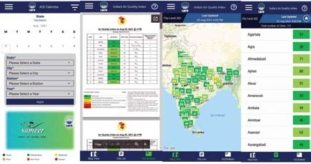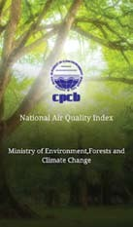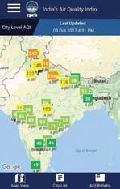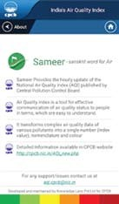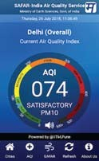Air Quality Monitoring Sensors

- Air quality monitoring sensors, also known as air quality sensors, identify the presence of air pollutants in the surrounding area.
- These devices can be small or large, low cost and high cost depending upon the accuracy and precision of the air quality data.
- We can use these sensors to identify the air quality of our nearby regions in both indoor and outdoor environments.
- By using air quality sensors, one can make a decision to reduce exposure to harmful air pollutants.
- Air quality sensors mainly quantify particulate matter (PM₁₀, PM_{2.5}), carbon mono-oxide, ozone, sulfur dioxide, nitrous oxide, and volatile organic carbons.

Real-Time Air Quality Monitoring

The air quality of any place can be assessed by using many online available tools and applications. You may install various air quality monitoring apps on your phone to identify the air quality of your nearby region.
- Sameer is an official app by the Indian Central Pollution Control Board. Sameer app provides the air quality data on an hourly basis for all cities and towns. It has been considered as an accurate tool for getting real-time air quality information near your place. This app also provides graphical and map layout appropriate colour coding information.
https://play.google.com/store/apps/details?id=com.cpcb
- The SAFAR (System of Air Quality and Weather Forecasting and Research) is a project of Ministry of Earth Sciences, Govt. of India having distinction to develop India’s first ever Air Quality Forecasting system SAFAR for Metro cities.
http://safar.tropmet.res.in/

Brief Overview of the Graded Response Action Plan (GRAP)
GRAP has been formulated for Delhi and its neighboring states to implement control measures under different air quality from moderate to severe. In GRAP, there is a list of various measures government authorities take to prevent severe air quality of Delhi and its adjoining areas. GRAP has been designed to reduce the level of particulate matter (PM10, PM2.5) beyond the ‘moderate’ national Air Quality Index (AQI) category.
If air quality reaches the severe+ stage, GRAP talks about shutting down schools and implementing the odd-even road-space rationing scheme.
Category | Ambient Particulate Matter | Measures
Moderate to Poor | - PM2.5 between 61-120 μg/m  3  - PM10 between 101-350 μg/m  3 | - Enforce pollution control in thermal power plants  - Mechanized sweeping on roads  - Ban on firecrackers  - Stop garbage burning
Very Poor | - PM2.5 between 121-250 μg/m  3  - PM10 between 351-430 μg/m  3 | - Stop use of diesel generator sets  - Increase bus and metro services and increasing frequency of metro service  - Stop use of coal/firewood in hotels and open eateries
Severe | - PM2.5 more than 250 μg/m  3  - PM10 more than 430 μg/m  3 | - Increasing frequency of mechanized sweeping of road and sprinkling of water on roads  - Close brick kilns, Hot Mix plants, Stone Crushers  - Shut down Badarpur power plant  - Introduce concessional rates to encourage off-peak travel in public transport
Severe = or Emergency | - PM2.5 more than 300 μg/m  3  - PM10 more than 500 μg/m  3  (persist for 48 hours or more) | - Stop entry of diesel trucks into Delhi (Except essential commodities)  - Stop construction activities  - Introduce odd and even scheme  - Shutting of schools

National Ambient Air Quality Standards (NAAQS) are the regulatory measures to set the target for pollution reduction and achieve clean air in the outdoor environment. Central Pollution Control Board (CPCB)- It is a pollution regulatory organization under the Ministry of Environment, Forest and Climate Change (MoEFCC).
Definitions
- Graded Response Action Plan
https://cpcb.nic.in/uploads/final_graded_table.pdf
- CPCB Air Quality Calculator
https://www.google.com/url?sa=t&rct=j&q=&esrc=s&source=web&cd=&cad=rja&uact=8&ved=2ahU KEwjypda9hZLyAhUQ6XMBHfohDZQQFjAAegQIBRAD&url=https%3A%2F%2Fapp.cpcbccr.com%2Fccr_ docs%2FAQI%2520-Calculator.xls&usg=AOvVaw12DDNIS8q_Lj89UQRNp41D
- Real-Time AQI websites https://www.aqi.in/ https://aqicn.org/map/india/
Relevant Data

Self Assessment:

Question 1. There are two different seasons- the rainy season and the winter season. Please tell that-

A Which season do you enjoy most outdoor activities- rainy or winter?

B In which season, you feel that you are taking fresh air?

C In the winter season, which activities deteriorate air quality?

Question 2. How will you assess that you live in a good air quality region? What kind of tool help in assessing the air quality of your area?

Question 3. Monitor your area’s air quality using the Sameer app for a week. Make a graph on an excel sheet for PM10, PM2.5, and AQI levels for a whole week. Analyze the results, that on which day, you get more clean air?

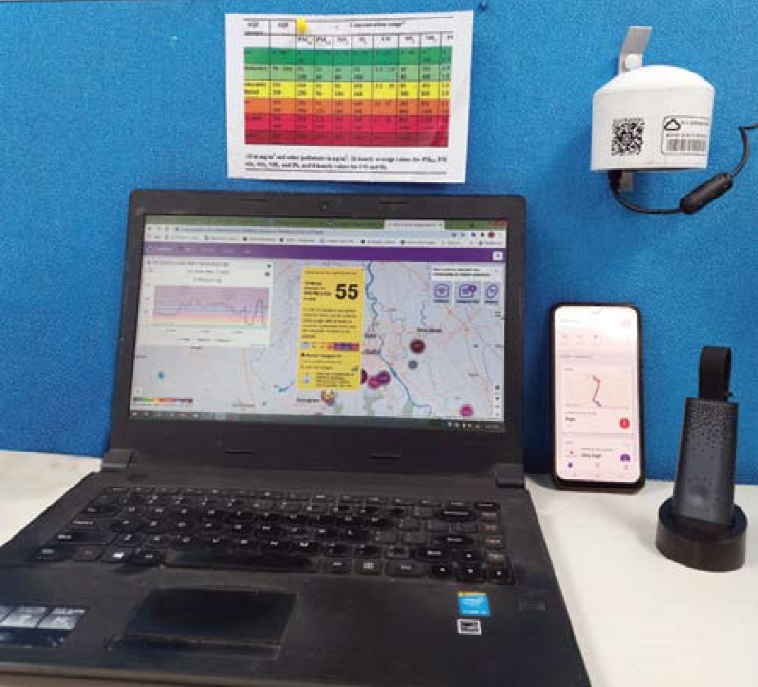
Learning Module

4
SENSORS AND ITS APPLICATION IN AIR QUALITY MONITORING
An Overview

Learning Themes
  - What are air quality sensors and monitors

Learning Objective

To know about basic tools/equipment for measuring air quality
- To understand how air quality data is collected using sensors

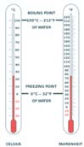What is a sensor?

A sensor is a module, device, machine, or subsystem that produces an output signal to sense a physical phenomenon. A sensor can detect events or changes in the environment and respond to some output on the other system. The input from the physical environment could be heat, motion, pressure, moisture, air pollutants, etc. A sensor converts a physical phenomenon into a measurable analog voltage (or sometimes a digital signal) converted into a human-readable display or transmitted for reading or further processing.
Sensors are connected through gateways, which enable them to relay the collected data to a server in the cloud. From there, the information is transmitted to a computer or cell phone for instant access.
Example: In a mercury or alcohol-based thermometer (Fig. 1), the physical property being measured is temperature. The mercury/ alcohol expands proportionally with a rise in a specific amount of temperature in the thermometer’s capillary tube, indicating a number in human-readable form.

Fig. 1. Two mercury thermometers measuring the same temperature in different unit scale

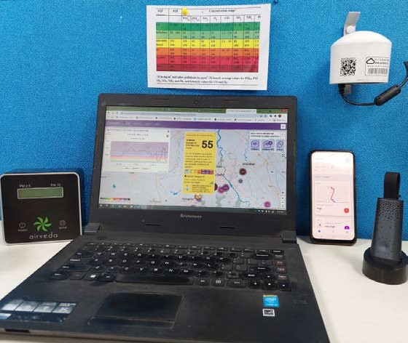What is an Air Quality Sensor?

An air quality sensor monitors the presence of air pollutants in the surrounding area. They can be used in both indoor and outdoor environments.
There are various types of air quality sensors; some of them are:
- An electrochemical sensor is based on a chemical reaction between gases in the air and the electrode in a liquid inside the sensor. These sensors measure NO₂, SO₂, O₃, NO and CO.
- Photoionization detector ionizes volatile organic compounds and
measures the resulting electrical current.
- Optical particle counter detects particulate pollution by measuring the
light scattered by particles
- An optical sensor detects gases like carbon monoxide and carbon
dioxide by measuring the absorption of infrared light.
- Metal oxide sensor is used to measure NO₂, O₃, CO, SO₂, etc. MOS sensors measure gas concentrations by measuring the resistance change in the metal oxide as a result of gas adsorption.
Air quality sensors can estimate a variety of pollutants such as dust, fine particulates, oxides of nitrogen, carbon dioxide, carbon monoxide, ozone and others.

What is Particulate Matter (PM)?
Air pollution is now recognized as the single biggest environmental threat to human health (WHO, 2021). Ambient air pollution and atmospheric aerosols have been classified as carcinogenic by the International Agency for Research on Cancer (IARC) (Loomis, Huang, & and Chen, 2014). Especially, Particulate Matter (PM) is a mixture of solid particles and liquid droplets suspended in the air. These are inhalable and hence affect our health by penetrating deep inside the lungs. These particles have different properties like shape, size and composition. These PM particles are denoted in the nomenclature of PM_{X}, where X is the maximum particle diameter. For example, PM_{2.5} defines particles with a diameter of 2.5 micrometres or smaller, and PM₁₀ defines particles with a diameter of 10 micrometres or smaller. PM values are measured as ‘mass concentration’ in μg/m3.

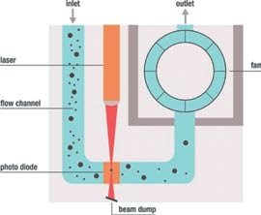How is Particulate Matter measured?

Gravimetric method- A pre-weighed filter is used to collect particles that are pre-sorted physically (e.g. only particles less than 2.5 micrometres are let in). At the end of sampling (24 hrs usually), the filter is weighed to find the accumulated PM in micrograms. When this is divided by the volume of air that passes through the filter in 24 hrs, we get the mass concentration in microgram/m3.
Limitations of this Method: These instruments are bulky and expensive. They process only one PM size per measurement (e.g. PM2.5). The real-time sampling is not possible – 24 hrs
Real-time Optical Particle Counters (OPC): These instruments are low-cost. They are based on different optical principles such as scattering or absorption. In these instruments, the particle passes through a light source and causes scattering or absorption of the incoming light. It is then detected by a photodiode and converted into real-time particle count and mass concentration values.

Fig. 2. Working principle of a Particulate Matter Sensor with different components

(Source: Sensirion; Source: https://www.sensirion.com/en/about-us/newsroom/sensirion-specialist-articles/particulate-matter-sensing-for-air-quality-measurements/)
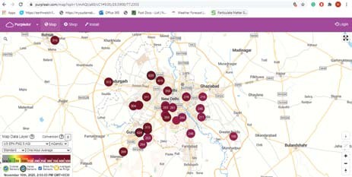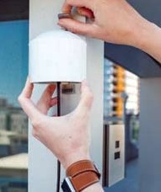

Currently, optical detection is the most used technique, mainly due to its ease of use and cost-performance ratio.
In recent years, Optical Particle Counters (OPC) have become small enough to be integrated into air quality monitors, air conditioners and air purifiers. They are used to monitor air quality in indoor and outdoor environments.
These low-cost monitors use Wi-Fi or cellular networks to relay the information to the server. People can see the real- time PM concentrations on their computers or mobiles.

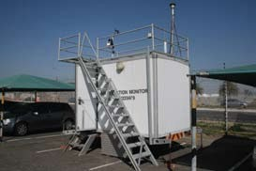
Reference Grade Monitors
These are huge air quality monitors usually installed by the government. They have strict standards of measurement performance. These monitors give high-quality data that help scientific studies and aid in decision-making and policymaking. The main drawback with these monitors is that they cannot be deployed extensively for hyper-local monitoring due to
their high costs.
Fig. 3. A picture of a continuous ambient air quality monitoring station. The Inlet of the instruments/analyzers is above the rooftop. Generally, the sampling inlets should be free from any hindrance (3/4th area should be open for the wind to flow). Met data are simultaneously measured at these sites.

Air Quality Monitoring with Satellites
Do you know that even satellites like NASA’s MODIS (or Moderate Resolution Imaging Spectroradiometer) help monitor air pollution? One type of measurement, “Aerosol Optical Depth’ measures the density of aerosol particles by measuring the difference between solar radiations at the top of Earth’s atmosphere and the surface of the Earth.
The drawback with this method is the weather condition can easily affect the measurements. Also, as it is dependent on sunlight, it can’t measure correctly on a cloudy day.

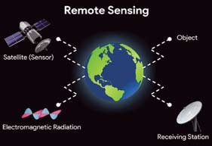Air Quality Monitoring using Satellites

For every square kilometre of the Earth to be monitored, satellite remote sensing is the only viable method. There are several hundred satellites currently in orbit, and not all of them have instruments that are suited for air quality measurements.
Fundamentals of Remote Sensing-
Remote sensing is a scientific technique of obtaining information about an object or phenomenon through the analysis of data acquired by a device that is not in contact with the object or phenomenon under investigation. It simply means acquiring information from a distance. National Aeronautics and Space Administration (NASA) observes Earth and other planetary bodies using sensors onboard satellites and aircraft that detect and record reflected or emitted energy.
Atmospheric particulate matter (PM), especially PM2.5 (PM with an aerodynamic diameter less than 2.5 μm), is one of the major components of air pollutants. Satellite-derived PM2.5 is generated by converting “Aerosol Optical Depth’, which is the measure of aerosols (e.g., urban haze, smoke particles, desert dust, sea salt) distributed within a column of air from the instrument (Earth’s surface) to the top of the atmosphere. AOD can be used to derive PM2.5 where ground data is unavailable. A sensor like ‘Moderate Resolution Imaging Spectroradiometer’ (MODIS), that has been providing AOD

(Image source- https://studyprobe.blogspot. com/2020/06/remote-sensing.html)

retrievals for more than 11 years, twice daily (under cloud-free conditions) on a near-global basis with a high spatial resolution (10 km²) with good accuracy. It is a sensor operating on the Terra and Aqua satellites, which were launched by NASA in December 1999 and May 2002, respectively. Terra’s orbit around Earth is timed so that it passes from north to south across the equator in the morning, while Aqua passes south to north over the equator in the afternoon.

Research works using Air Quality Monitoring Sensors at IIT Kanpur:

Problem statement: what and why was the study conducted?
In 2017, there were fewer than 200 continuous air quality monitoring stations (CAAQMS) in India. Currently, in early December 2021, their number has risen to 327, covering 27 states and 169 cities. The regulatory agencies’ equipment was all imported from the United States or Europe at the time, with regulation-grade PM2.5 and PM10 BAM monitors costing upwards of Rs. 15 Lacs per monitor. Moreover, all criteria gas pollutants’ analysers cost upwards of Rs. 1.50 Crores per monitoring site. In India’s 7000+ census cities and towns, there was a clear need for continual air quality monitoring. But significant expenditures in expanding CAAQMS network densities in developing countries like India, on the other hand, would be both impracticable and expensive. Due to this limited number of stations, real-time continuous ambient air quality data for most of the areas is cumbersome. The emergence of low-cost sensors in recent times has provided the scientific community with a potential solution to address this issue, which could complement the existing limited number of CAAQMS. Researchers at IIT Kanpur, in collaboration with other national and international institutions, have conducted various research project works which aimed at fundamentally redefining the air quality monitoring in India. They are one of the pioneer teams in India to scientifically validate their low-cost sensors in diverse environmental field conditions and to use them for further monitoring air quality at the city scale. The focus of these studies is on the evaluation of low-cost sensors, with a particular emphasis on technical performance during field calibrations.

Works done by IIT Kanpur – Towards low-cost and high-performance of gaseous and PM pollutants using machine-learning analysis or techniques:

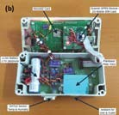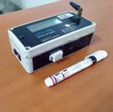Problem statement: what and why was the study conducted?
We evaluated LCAQMS in the SATVAM project and summarized the outcomes from our numerous deployments of sensor node networks throughout India. Very low-powered wireless network solutions based on peer-to-peer 6LoWPAN technology and energy harvesting-powered IoT systems have been implemented in the field for the first time in India1. Our results revealed that edge and cloud-based services interacted successfully with the mesh network to deliver data. Statistical analyses for the LCAQMS swap-out experiment in Delhi and Mumbai, using the robust calibration of sensors in diverse urban settings, showed that incorporating RH and temperature features into the calibration model improved calibration performance. A novel local non-parametric Machine Learning (ML) calibration algorithm based on metric learning (k-Nearest Neighbour distance metric learning) that offered, across deployment sites and phases, an R2 up to 0.92 and 0.82 with respect to reference values for ozone and NO₂ calibration, respectively2. It showed a 4–20% point improvement in terms of R2 values offered by classical non- parametric methods. In another study conducted as a part of SATVAM project, it was estimated that with co-located calibration, the RH corrected LCAQMS measured PM2.5 concentrations are within10% of ambient values3. The PM₁₀ concentrations from the un-calibrated LCAQMS co-located with research-grade instruments were also evaluated in two sites in Delhi, and the correlation was found up to 0.84. A novel method for a Gaussian process regression based on the fly sensor calibration was also developed using PM_{2.5} LCAQMS deployed in Delhi5. The approach used a leave-one-out cross-validation method over the 22 reference nodes and showed an overall prediction error of 30% (RMSE 33 μg m−3) at a 24 h scale.

Figure 8. (a) Image of IIT Kanpur’s low-cost particulate matter (PM) sensors at one of the study sites (b) various components of a PM monitoring device.
Source: Sahu R, Dixit KK, Mishra S, Kumar P, Shukla AK, Sutaria R, Tiwari S, Tripathi SN. Validation of Low-Cost Sensors in Measuring Real-Time PM10 Concentrations at Two Sites in Delhi National Capital Region. Sensors 2020, 20(5), 1347; https://doi.org/10.3390/s20051347

In an ongoing project with Maharashtra Pollution Control Board (MPCB), four start-ups deployed the LCAQMS with the co-location of reference monitors in the Mumbai Metropolitan Region. Two start-ups deployed the LCAQMS at 15 locations, and the other two deployed the LCAQMS at five locations for the duration of seven months. In this work, we proposed a calibration method that could minimize the co-location time of LCAQMS with a reference monitor. Hence, we have proposed a domain adaptation-based calibration method for PM2.5 measured using LCAQMS. In this method, first, a base calibration model is developed at one site (source location) with a longer co-location duration. Further, the model is adapted at the target location with a shorter co-location duration. The proposed calibration model requires two days of data for adapting to a target location. The proposed model achieved an R2 up to 0.88 and MAPE as low as 9.49%6. We also proposed a Model-Agnostic-Meta-Learning (MAML) based model for the LCAQMS calibration, which showed the RMSE as low as 10.3 μg m-3 in PM2.5 measurements7.
In another ongoing study on sensors deployed in Delhi NCR, Kriging technique-based model was developed using measurements of CAAQMS and LCAQMS to predict PM2.5 concentration with a MAPE of less than 20%. We conclude that these deployed LCAQMS networks offered much-needed huge datasets from a variety of urban contexts, which improved our understanding of pollution levels at specific locations. Application-based large-scale multicity dense LCAQMS network deployments are also underway in three major cities in India. These strategic deployments of sensors will be focused on one to several aspects of air pollution issues in three cities with distinct geographical and environmental features in India. Another LCAQMS based Indo-US project aims to improve the air quality and human health in the South-Asia region through capacity building with local government and private sector partners. The overall goal is to develop and implement plans to reduce PM2.5 concentration in highly polluted regions in each country through a combination of low-cost satellite image enhanced PM2.5 sensor networks integrated with meteorological modeling and source apportionment. We will also apply micro-satellite images with an ML approach to estimate PM2.5 concentrations at a finer resolution. The LCAQMS network can also assist in having a robust framework to monitor PM2.5 concentrations, determining specific sources and developing a strategy to reduce PM2.5 levels to improve air quality.
Hybrid monitoring, i.e., Regulatory Monitors’ (FEM/FRM) data + Low-Cost Sensors Data + Satellite Data
Hybrid Monitoring is proposed for all National Clean Air Programme Cities. All Non-Attainment Cities need dense air quality monitoring to detect hotspots, provide relevant health advisories to citizens, and evaluate NCAP targets and to build evidence-based policies for air quality. Regulatory-Grade (FEM/FRM) monitors are accurate but expensive (as already mentioned). Further, all continuous FEM/FRM monitors are imported, and their procurement is not aligned with the Atma Nirbhar Policy of the Government of India. On the other hand, a low-cost sensor is a rapidly emerging developing technology being used globally by several government regulators (EPA, UK Government, etc.) for citizen-focused air quality solutions. However, there is a definite need for well-defined field evaluations and technical performance metrics.
While Satellite data only gives 2 data points per location per day based on Aerosol Optical Depth (AOD). Both temporal frequency and coverage are an issue as well. Yet, an advantage of satellite monitoring is that long-term trends are feasible. Accuracy is also an issue as AOD is a retrieved quantity, and PM2.5 is estimated on retrieved AOD. So, the role of these sensors becomes very important to attain air pollution data at a much higher resolution for ground measurements of air quality and other parameters.
Way forward:


Learning Module

5
AIR QUALITY AND ITS EFFECT ON HEALTH
An Overview

Learning Themes
1. Air quality and human health

Learning Objective

To associate AQI and human health
- To know which segment of the population is most vulnerable

Understand long-term impact of poor air quality on health
- Take positive individual actions to improve air quality

Evidence of Leaning
1. Information leading to action and informed decisions

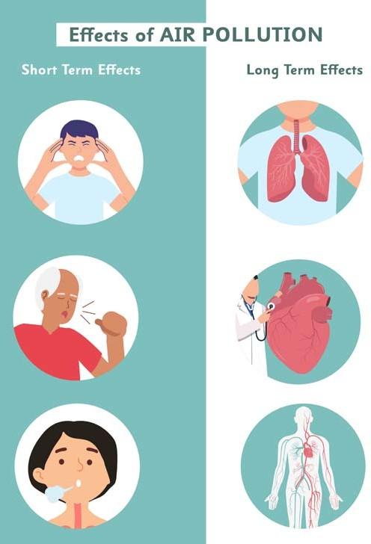
Air Quality and Human Health
In the previous modules, we learned about the concept of the Air Quality Index. With the help of AQI, we can assess the air quality and potential health risks. Studies have shown that most people have various health impacts due to pollution during their outdoor activities, including headache, insomnia, breathing issues, shortness of breath, irritation, and many more. These symptoms vary from person to person and different age groups.

Air pollution- a silent and invisible killer
Air is getting polluted with harmful substances with damaging health effects. The toxic substances in the air may come from natural sources and human-made sources, as explained in the earlier modules.
Exposure to air pollutants can have effect on human health such as asthma attacks, respiratory symptoms, chronic bronchitis, eye irritation, and other diseases; on material and structure such as corrosion of metal, effect on monuments and buildings; on ecosystem such as atmosphere, waterbodies and soil and also on acid rain and climate change
This module will focus on the health impact of air pollution. Toxic pollutants like nitrogen oxides (NO_{X}), sulphur dioxide (SO₂), particulate matter (PM), and ozone (O₃), when mixed in the air and inhaled at harmful levels, cause a negative impact on human health. Out of all the pollutants, PM2.5 is of significant concern, as it can penetrate deep into the lungs. It affects both the respiratory and vascular systems of the human body. Multiple studies focus on the association between air pollution and various health effects.

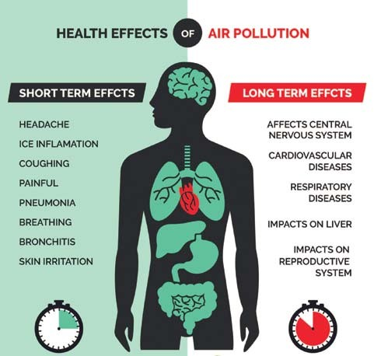Health impacts of air pollution

Studies show that air pollution causes and intensifies several diseases such as respiratory illness, heart disease, increased hospital admissions and many more.
Air pollution impacts our health in a number of ways such as acute respiratory infections and chronic bronchitis. Pollution can worsen condition of people with preexisting heart or lung disease. Amongst those with asthma, air pollution has been shown to aggravate the frequency and severity of attacks. Short-term and long-term exposures have also been linked to premature mortality and reduced life expectancy.
Short-term health effects of pollution: These effects are temporary and symptoms have been observed in a few days or just after the exposure of the pollutants such as headache, insomnia, nausea, dizziness, coughing, breathing issues, increase in heartbeat, irritation to nose, throat, eyes and skin, lack of sleep, discomfort, lack in concentration, fever, pneumonia, bronchitis, asthma etc.
Long-term health effects of pollution: The long-term effects of air pollution can last for years or may persist for a lifetime. These are the health effects whose symptoms have been observed on long term basis such as accelerated ageing of the lungs, lung dysfunctions, heart disease, lung cancer, respiratory diseases, asthma, bronchitis, emphysema, and many more. Air pollution can also cause long-term damage to the human nervous system, kidneys, and other organs.

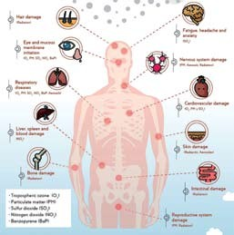

Health impact of air pollution depends on the type of pollutant, concentration of the pollutant in the air, length of exposure and individual susceptibility.
For example, those who are undernourished, very young and very old, and people with preexisting respiratory disease and other ill health, maybe more affected by the same concentrations than healthy people.

Air pollutants, their sources and possible health effects from exposure

Outdoor air pollution
The major outdoor pollution sources include forest fire, burning of waste and biomass/stubble burning, emissions from vehicles, smoke from industries, waste incineration, roadside construction debris etc. Outdoor air pollution gets intense during winter and during excess firecrackers. Such events create a thick layer of smog blanketed over the cities and cause itchy throats, watery eyes and lack of visibility. The length of exposure, amount and type of pollutants are important factors to cause health effects.

Indoor Air pollution
Household air pollution is generated by fuel combustion for cooking and heating purposes. Inefficient combustion of solid fuels such as wood, coal, charcoal, crop waste, dung and kerosene is one of the key environmental risks to human health. Exposure to indoor air pollution is associated with several disease outcomes, such as acute lower respiratory infections (e.g. pneumonia), chronic obstructive pulmonary disease, cardiovascular diseases and other ailments.

Air pollutants Sources Health Impact

Particle pollutant-PM_{2.5}, PM₁₀
Industries, vehicles, smokes Respiratory and cardiovascular diseases, reproductive system dysfunction

Sulphur dioxide (SO₂) Coal-burning, fuel combustion, petroleum refineries Respiratory discomfort, irritation in eyes, more frequent asthma attacks in
people with asthma
Nitrogen dioxide (NO₂) Vehicular exhaust, fuel combustion Damage to organs- liver, lung spleen

Carbon mono-oxide (CO) Industries, from incomplete burning of fuels such as
petrol and diesel
Damage to the nervous system and cardiovascular system, impaired vision and coordination when exposed to high levels

Ozone (O₃) Industries, vehicular emission Respiratory and cardiovascular dysfunction, Irritation and inflammation of
eyes, nose, throat and lower airways: coughing, sore and scratchy throat or uncomfortable feeling in the chest
Lead (Pb) Leaded petrol, industries, lead smelting Nervous system and hematologic discomfort, irritation in eyes

Risk factors for air pollution

The risk for any disease related with the air pollution depends upon various factors such as-
- Current health status - whether having any lung or heart-related diseases, i.e., respiratory and cardiopulmonary diseases.

- Age of the person - It has been observed that children and older people are at more risk for the harmful effects of air pollution.
- Type of pollutant - Different air pollutant causes different health effects. For example, PM_{2.5} is more harmful to human health compared to PM₁₀; as finer the particle, the more is the health effects, as they can easily penetrate deep into the lung system.
- Level/Concentration of the pollutant - More is the pollutant level in the air, more are the harmful effects on the body. For example, during winter, the level of air pollutants in outdoor air is much higher.
- Duration of exposure - It depends upon how much time you are exposed to unhealthy time. More is the exposure, more profound will be the health effects.
- Occupation of the person - It has been observed that the people who are working in industries, workers near petrol pump stations, traffic police, roadside vendors, and commuters travelling daily in polluted regions are at more risk because they are exposed more to poor air quality.

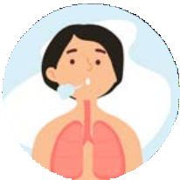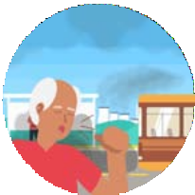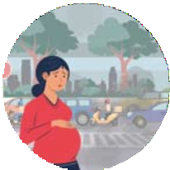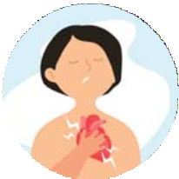
Who is affected more by the harmful effects of air pollution?
People with lung
diseases
Infants and young
children
Elder People
Pregnant women
People with
cardiovascular disease
People who smoke People who work
outdoors or working in occupations where there is high exposure to contaminated air
Who is most at risk?
Air pollution can affect all age groups. However, some people are sensitive to common air pollutants such as particulates and ground-level ozone. Sensitive populations include children, older adults, people who are active outdoors, people with heart or lung diseases, such as asthma and pregnant women. Older adults and children or people with heart (or lung) disease are subject to much more significant risk from particles than other people. In addition, young children and older adults, whose immune systems tend to be weaker, are more sensitive to pollution.

Effect of Air Pollution on Children and Elder People
Several factors explain why the risks for young children and elders are highest. While children are still growing, air pollution harms them during their developmental stage, causing long term health problems. Inhaling the smog can have negative impact on the health of elderly. As age increases, our bodies are less capable of fighting off the inflammation and other damage caused by air pollution. When people become elder, their body organs have already worked so much, at more old age their immunity become so weak and they are more susceptible towards the harmful effects of air pollution.

- Turn off the car engine when the traffic signal is red.
- Avoid unnecessary outdoor activity at the locations where air pollutant levels are higher.
- Citizens should be encouraged to use bicycles.
- Encourage carpooling and use of public transport at a larger scale by supporting the Metro, overhead rail and bus services.
- Use of cleaner fuel like CNG in motor vehicles in place of petrol or diesel.
- Avoid biomass burning and stubble burning.
- Maintenance of poor road and construction sites as they are the major sources of coarser particulate matters.
Actions to prevent air pollution


Learning Module

6
WHAT CAN WE DO TO IMPROVE AIR QUALITY?
An Overview

Learning Themes

Positive actions to improve air quality individually and collectively

2
Use public transport, encourage carpooling
3
Reduce vehicle idling at traffic signals
6
Plan outdoor activities in less polluted time of the day
8
Plant trees and increase the green cover
11
Chimney for kitchens, Clean chimney filters
12
Use clean fuel for cooking to reduce household air pollution
15
Save energy at home, office and school
Positive Actions
Walk for short distances, Use bicycle where possible

CNG vehicles
Regularly monitor the AQI and reduce your exposure to pollution

Sustainable waste management
Choose eco-friendly products
and energy efficient devices
17
practices, Encourage recycle and reuse
13
9
Electric vehicle Clean-fuel vehicles
5
1
16 Switch off the lights and electronics when not in use
Use energy efficient appliances
14 Be aware of the pollution caused
by firecrackers
10 Minimize use of single-use plastic Donot burn plastic waste
7 Increase use of fans,
Careful use of air conditioners for energy efficiency
4 Choose alternate /
lesser polluted routes based on AQI information
Background
Every one of us can help in improving air quality. We all can make a difference by changing the way we travel, the energy we use, the waste we generate, and our lifestyles. This module documents some positive actions at individual and community levels to reduce air pollution.


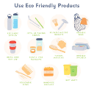

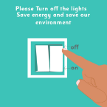




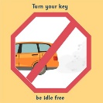




Guidance notes
- Walk to work/ Use Public transport/ Use bicycle
Walking to work, greater utilization of public transport and cycling can help reduce the emissions produced from private vehicles by reducing the number of vehicles on the road.
- Recycle, reuse and compost the waste
Recycling and reusing help conserve resources and reduce pollution caused during extraction and processing of raw material, preventing emissions of many greenhouse gases water pollutants and saving energy.
Composting is a form of recycling wherein organic waste (food, yard waste etc.) is converted into new soil. Composting helps in reducing waste.

- Switch off the lights and electronics when not in use /buy energy-efficient appliances
Switching off of lights and electronic appliances when not in use and purchasing energy-efficient appliances helps save energy, lower energy demand, and reduce emissions from power plants.
- Using fans instead of air conditioners
Air conditioner consumes a lot of energy¹. Air conditioners, being the major source of household energy consumption, peak the energy demand, especially on hot summer days, increasing power consumption and energy demand. Air conditioners are also one of the key drivers of GHG emissions, which significantly impact the environment (by contributing towards the greenhouse effect). Minimizing the use of air conditioners at home/offices/schools and using fans instead (whenever possible) can help reduce greenhouse gas emissions.
- Use of filters for chimneys
Using filters for chimneys at home/ industries helps trap dust and particulate matter present in the smoke, reducing the amount of pollutants released into the air.

- No crackers
Firecrackers are made up of chemicals, some of which are highly toxic. After firing crackers, the smog contains sulphur oxides, nitrogen oxides and particulate matters that may increase the concentration of dust and pollutants in the air. These particles settle on the surrounding surfaces polluting the environment.
- Reduce the use of plastics
Plastic is made up of chemicals sourced from crude oil, coal or natural gas (fossil fuels and petrochemicals). Studies suggest that about 12% of municipal waste is made up of plastic, and almost 41% of the world’s waste is burned. Plastic waste’s burning significantly contributes to air pollution by releasing toxic gases such as mercury, dioxins, and polychlorinated biphenyls into the environment.
Limiting our use of single-use plastic (such as Straws, candy wrappers, plastic bags used for packing, plastic bottles, etc.) can help reduce emissions of pollutants released in production and reduce the amount of waste generated.
- Plant trees/ increase the green cover
Trees help in improving air quality in two ways- direct and indirect. Indirectly, trees can reduce the temperature by trapping heat and mitigating the greenhouse effect. Lower temperature decreases the need for air conditioning, reducing the energy demand that commonly spikes during summers in urban areas.
Trees help improve air quality by absorbing harmful pollutants (particulate matter-nitrogen oxides, ammonia, sulphur dioxide). Trees absorb these harmful pollutants through dispersion and deposition². Therefore, increasing green cover in and around the city can help improve air quality.

¹UNEP (2020). Cooling Emissions and Policy Synthesis Report:, “In 2015 air conditioners installed in 150 developing countries were responsible for 640 million tonnes of carbon dioxide equivalent (CO2e) emissions1 , or approximately 2 per cent2 of the global energy-related CO2 emissions in 2014”
Traverso V. (2020). Future Planet- BCC. The best trees to reduce air pollution. https://www.bbc.com/future/article/20200504-which-trees-reduce-air-pollution-best.
²“The first one is dispersion – by crashing into trees and plants, concentrated clouds of minuscule particles get dispersed and so diluted by the air, decreasing the risk of inhalation by humans. The second one is deposition. PM can easily get trapped in the waxy, hairy leaves of trees and shrubs. When it rains, most of these particles are washed away by water into drains”

Urban heat island effect
Urban heat island is an urbanized area that experience higher temperature than its outlying surrounding areas. The urban heat island effect is a microclimatic phenomenon affecting urban areas due to changes in land cover/surface caused due to urbanization, including a decline in green cover and dense concentration of buildings, pavements, roads, and other structures that absorb and retain heat. As a result, the urban heat island effect significantly contributes to air pollution and climate change.
- Check AQI ) and reduce your exposure to pollution
Checking the Air Quality Index of the area can help people plan their daily activities (exercise, cycle, going out for shopping etc.). The higher value of AQI indicates a greater level of air pollution and greater health concerns. Therefore, by making an informed decision based on AQI, one can reduce exposure to air pollution.
- Plan your daily activities in less polluted time of the day
A greater level of air pollution and greater health concerns. By planning daily activities in a less polluted time (based on AQI), we can reduce our exposure to air pollution.
- Idling of vehicle at traffic signals
Idling of a vehicle refers to running a vehicle’s engine when it is not moving—idling vehicles while at traffic signals or being stuck in traffic jams causes a huge amount of wastage of fuel and results in the emission of lots of pollutants into the environment—practicing to switch off vehicles while in such situations leads to fuel-saving and reduction in vehicular emission.
- Use of clean and sustainable energy sources for cooking
Cooking using solid fuels (wood, coal, charcoal, dung) and kerosene produces a high level of indoor (household) pollution by causing the emission of health- impacting harmful pollutants. Adopting renewable, clean and sustainable energy sources (LPG, Biomass or ethanol-based fuel) helps reduce indoor air pollution.
- Do not burn the waste
Waste burning releases harmful pollutants such as dioxins, furans and black ozone into the atmosphere. According to an estimate, 41% of global waste is burned openly³. These pollutants cause severe long-term health impacts in humans. Therefore, the burning of waste in open spaces must be avoided. Improved waste management strategies such as improved collection, disposal, segregation, and recycling must be practiced at all levels.
- Carpooling
Carpooling helps in reducing the number of vehicles on the road, thereby reducing vehicular emissions.

- Choose eco-friendly products
Eco-friendly products do not harm the environment whether in their production, use or disposal. Adopting eco-friendly products in our daily lives helps reduce air pollution by consuming lesser energy and producing lesser emissions during different stages of the product lifecycle.

³ Cogunt A. (2016). Open Burning of Waste: A global health disaster. “An estimated 41% of global waste is burned openly. In developing, low income countries that figure is even higher”

- Save energy at home/office/school
Saving/conserving energy helps in reducing energy demands. Decreased energy demand reduces the amount of emissions and consequent environmental impacts. Some of how we can conserve energy at home, school, offices include the following:
Adopting energy-efficient technologies and devices, limiting usage of electronics, reducing usage and wastage of paper, using a reusable water bottle, solar panels for energy needs etc
- Drive an electric vehicle
Unlike traditional motor vehicles, electric vehicles run on electricity (which uses diesel or petrol). Therefore, electric vehicles emit lesser air pollutants and GHGs than petrol or diesel counterparts (considering production and electricity generation). Moreover, even with electricity generation required to run an electric car, the carbon emission is almost 17-30% lower than driving a diesel or petrol car⁴. Therefore, electric vehicles are effective solutions to air pollution.
- Alternate routes (lesser polluted) based on AQI information
Commuters’ exposure to air pollution can differ considerably depending upon the route taken between home to work/office/school, and vice-versa⁵. Based on the AQI information, commuters (who often have a range of options of route choices available) can choose which route to take. Therefore, Air Quality Index information can help commuters in route planning and making informed decisions to reduce their exposure to air pollution
- Flagging up the AQI status
Schools/ RWAs can adopt the flag system; the flags, ranging from green, for healthy air quality, to red, for poor air quality, can help in guiding community members/ teachers/students on whether or not to hold outdoor activities.
Level | Strategies
Local /individual | Control of local activities generating pollution such as avoiding waste burning especially plastic waste, construction activities, unpaved/dusty roads and others
Local /individual | Congestion management at traffic junctions
Local /individual | Awareness and capacity building include generating public enthusiasm in accessing Air Quality Index (AQI) at the local level to reduce their exposure to air pollution and improve air quality
National / Sub-national (city) | Air Quality Monitoring
National / Sub-national (city) | Waste management
National / Sub-national (city) | Vehicular Emissions and Traffic & Parking management
National / Sub-national (city) | Public transport
National / Sub-national (city) | Graded response action plan
National / Sub-national (city) | Industries
⁴European Environment Agency (2018). Electric vehicles from life cycle and circular economy perspectives. TERM 2018: Transport and Environment Reporting Mechanism (TERM) report
⁵Rafiepourgatabi M. et al.(2021). The Impact of Route Choice on Active Commuters’ Exposure to Air Pollution: A Systematic Review. Frontiers in Sustainable Cities. https://www.frontiersin.org/article/10.3389/frsc.2020.565733

National / Sub-national (City) Strategies

Industries
Air Quality Monitoring
City-Air pollution Planning
Waste management
Public transport
Vehicular Emissions and Traffic & Parking management

Air pollution is a cross-cutting issue involving waste management, industries, traffic management, among other sectors. Therefore, addressing air pollution requires a multi-sectoral approach. This section discusses some of the key actionable points to reduce air pollution at national/sub-national levels (city) through sectoral interventions. These points provide reference to policymakers (municipal bodies, urban local bodies, etc.) in planning strategies to reduce, mitigate and prevent air pollution through community/sectoral actions. At the same time, these action points empower citizens to take up actions at individual or community levels while drawing an understanding of the highly cross-sectoral dimension of air pollution in society.

Good practices across different stratrgic areas

Air Quality Monitoring and capacity building
Air quality monitoring provides the requisite tool for taking effective and scalable actions to mitigate and prevent air pollution and its impact on human health. Therefore, building capacity by enhancing data monitoring and dissemination systems is crucial for effective engagement of various stakeholders (civil society organizations, research and academic institution, communities, policymakers, etc.) to improve air quality. Some key actions for the same are mentioned below:
- Monitoring of Ambient air quality
- Strengthening Ambient Air Quality Monitoring Systems by setting up new and up-gradation of existing Ambient Air quality monitoring stations and establishing a hyper-dense network of monitoring systems for localized datasets.
- Conducting source apportionment study
- Dissemination of air quality index to the public through websites and other media.
- Knowledge and understanding of regulation, policies laws on air pollution for compliance

Transport: Vehicular emissions, Traffic and Parking management
Effective management of vehicular emissions, traffic, and parking systems helps prevent air pollution and reduce the human exposure and health impact related to air pollution. Some of the actionable solutions are stated as follow:

- Odd-even plan for vehicles
- Phasing out of old diesel and petrol vehicles (cars)
- Regular checking of vehicular emissions and issue of pollution under control (PUC) certificates
- The green tax imposed on all vehicles entering a particular state, if registered outside of that state
- Green tax on older vehicles (a certain number of years)/ additional cess on all vehicles.
- Restriction on entry of vehicles visiting a particular place above a particular number.
- Planning transition to CNG and electric vehicles
- Introducing public bicycle sharing systems
- Introduction of cleaner fuel for vehicles and establishment of CNG/LPG stations
- Deployment of modern and scientific smoke emission detection devices at violation prone stretches
- Checking of fuel adulteration
- Promoting green transportation-construction of cycle tracks
- Cap on number of new registration each year, the introduction of a congestion tax in certain zones
- Even-odd parking policies for cars
- Parking policies and plans- Multi-storey parking places; Smart parking management – progressive on-street parking management system
- Making Bharat Stage IV norms mandatory. Bharat stage Emission Standards (BSES-BS Norms) instituted by the Government of India are emission standards to regulate air pollution. BS norms aim at regulating the output of air pollutants from motor vehicles caused due to internal combustion engines and spark ignition engines by promoting improved technologies. These standards were first introduced in 2000; since 2017, BS-IV has been enforced.

Construction and demolition waste and road dust
Common activities during construction such as using plants and vehicles on-site, land clearing and demolition, and using chemicals (glues, oils, thinners etc.) can significantly contribute to air pollution. This requires appropriate interventions to limit the impact of construction and demolitions activities on air quality. Some of these are mentioned below:

- Transportation of construction materials like sand, soil, stone chips etc. in covered systems
- Construction of pucca pavement along the road.
- Regular cleaning of road dust, water spraying on new/kacha roads through water tankers. Use of sprinklers to spray water to control road dust
- Ensuring air quality control measures during the demolition of old buildings and new constructions
- Measures to mitigate dust pollution from the construction industry
  - mandatory covering of transport carrying construction material
  - restriction on storage of construction material along the road
  - covering and screening operations through water sprinkling, curtains,
barriers and dust suppression units.
- Appropriate disposal of waste generated from construction and demolition sites
  - Creating infrastructure for Construction and Demolition waste management.
  - Provision of a decentralized network of construction and demolition waste
collection sites.
  - Preparing Debris management plan
- Creation of green buffers along the roads (traffic corridors). Plantation around industrial and residential areas. Greening /Development of green belt in open areas, gardens, park/community places, schools and housing societies
- Restrictions on Construction activities in higher polluted areas as an emergency measure

Waste management
Unsustainable practices around waste management right from generation, transportation and disposal have direct or indirect linkages with air pollution. Therefore, improved waste management strategies such as improved collection, disposal, segregation, and recycling are needed to reduce air pollution. Some of the ways to address the same are mentioned below:

- Restriction and regular check on waste burning (municipal solid waste, biomass, plastic etc.)
- Transportation and proper disposal of municipal solid waste and construction waste
- Regular cleaning of municipal drains
- Action plans to minimize forest fires (wherever necessary)
- Producing compost and bio-friendly products from biodegradable wastes (Bihar)
- Promoting waste composting plants at a city level
- Recycling plants for dry waste
- Ensuring waste segregation
- Banning single-use plastic
- Promoting waste to energy

Industry
Upgradation of industrial processes and technology, energy efficiency, fuel-source conversion, monitoring of industrial pollution can play a key role in reducing pollution by industries. Some key actionable solutions are listed below:
- Shifting to greener technology. Development of clean technologies
- Shifting of red category industries away from city area/outside city limits
- Setting up of new industries in industrial zones away from residential areas
- Adoption of cleaner fuel in industries. Conversion to CNG/PNG from coal as a fuel source
- Ensuring emissions standards in industries. At source emission monitoring, i.e. stack monitoring of industries
- Restriction of using unauthorized fuels
- Ensuring installation and operation of air pollution control devices in industries.
- Providing online continuous emission monitoring systems by all the red- large category industries
Public transportation
Enhancing public transportation systems with cleaner, sustainable fuels and technologies and better services are important to reduce air pollution. Some of the actionable solutions are listed as follow:
- Development of Intra-state/city Integrated /comprehensive mobility plan
- Phasing out old diesel and petrol public vehicles
- Increase fleet strength
- Increasing public transportation facilities on special occasions to cater to special demand
- Minimum fare – special fare policies
- Conducting comprehensive transportation studies
- Transition to Clean energy sources (electricity, bio-CNG, LNG, biodiesel etc.)

In order to address the issue of air pollution, the government of India has undertaken many steps. One of the most significant initiatives taken by the government is the launch of the National Clean Air Programme (NCAP); NCAP is the first committed national strategic framework for reducing air pollution with time-bounded reduction targets adopted by the government.
The target is to achieve a reduction in particulate matter concentration by 20% to 30% by the year 2024, taking 2017 as the base year. NCAP provides an overview of various ongoing government initiatives, including the National Air Quality Monitoring Programme, National Ambient Air Quality Standards (NAAQS), National Air Quality Index (AQI), and Forty-Two. Action Points (Section 18(1) of Air (Prevention and Control of Pollution) Act, 1986), Role of Environment Pollution (Prevention and Control) Authority (EPCA), Graded Response Action.
Policy intervention- National Clean Air Programme (NCAP)

Based on air quality data for the years 2014-2018, 122 non-attainment cities have been identified under NCAP. NCAP lays down the goal, target, objective, tenure, and approach and implementing agencies for National Clean Air Programme. In addition, NCAP emphasizes actions for mitigation, knowledge, and database augmentation and institutional strengthening for air quality management.
Plan (GRAP) and other measures

Graded Response Action Plan (GRAP)

In GRAP, there is a list of various measures government authorities take to prevent severe air quality in a particular region. GRAP has been designed to reduce the level of particulate matter (PM 10, PM 2.5) beyond the &#39; moderate&#39; national Air Quality Index (AQI) category.
GRAP lays down actions to be implemented under different Air Quality Index (AQI) categories, namely, Moderate &amp; Poor, Very Poor, and Severe as per National Air Quality Index. GRAP has been formulated for Delhi and its neighboring states to implement control measures under different air quality from moderate to severe.
For more information on policy intervention, visit:
- https://app.cpcbccr.com/ccr_docs/final_graded_table.pdf
- https://pib.gov.in/PressReleasePage.aspx?PRID=1593056
- https://moef.gov.in/wp-content/uploads/2019/05/NCAP_Report.pdf

